

Data Visualisation

Assignment 1



29 March 2024

Dhilan Thiyagarajah

Table of Contents

**First Task2**

Data Handling Policies2

**Second Task3**

Excel3

First Graph3

Top 20 graph10

**Third Task13**

Tableau 13

First Chart 17

Second Chart 21

Third Chart 25

Forth Chart 28

Fifth Chart 34

Dashboard 46

Dashboard Link 54

**Reflective learning55**

**First Task:**

In the UK businesses that are utilising data must abide by policies set by the UK General Data Protection Regulations under the Data Protection Act 2018. These policies allow businesses to handle data with care while preventing data from being misused. Several polices are laid out by GDPR include:

* Lawfulness, fairness and transparency – the data follows the law and does not hinder someone from using the same data.
* Purpose limitation – the data is in the scope of what the business is using it for.
* Data minimisation – data collected/used does not exceed what is needed for the service.
* Accuracy – the data is correct to reduce misinformation
* Storage limitation – the data cannot be stored for longer than is needed and reviewed the data held often. Data is erased or anonymised when you no longer needed.
* Integrity and confidentiality (security) - the appropriate safety measures are in place to protect the data being used to prevent unauthorised access.
* Accountability – taking responsibility for how to data is used and following the other policies

It is good practice to follow these policies when handling data, not just to avoid malicious intent but it is also the law. When the policies aren’t followed, substantial fines are given to business which can cause disruption in service. Fines of up to £17.5 million or 4% of your total worldwide annual turnover, which ever one is highest can be served.

***Source:***

*1)* [*https://ico.org.uk/for-organisations/uk-gdpr-guidance-and-resources/data-protection-principles/a-guide-to-the-data-protection-principles/*](https://ico.org.uk/for-organisations/uk-gdpr-guidance-and-resources/data-protection-principles/a-guide-to-the-data-protection-principles/)

*2)* [*https://www.gov.uk/data-protection#:~:text=The%20Data%20Protection%20Act%202018%20is%20the%20UK's%20implementation%20of,used%20fairly%2C%20lawfully%20and%20transparently*](https://www.gov.uk/data-protection#:~:text=The%20Data%20Protection%20Act%202018%20is%20the%20UK's%20implementation%20of,used%20fairly%2C%20lawfully%20and%20transparently)

**Second Task:**

1)

Excel 365 won’t be able to open or create password locked spreadsheets. This would require Excel desktop app where you would go to File → Info → Protect Workbook → Encrypt with password or Review menu on ribbon → Protect Workbook.

2)

I highlighted the column for GDP per capita. This highlights all the cells I want as £.

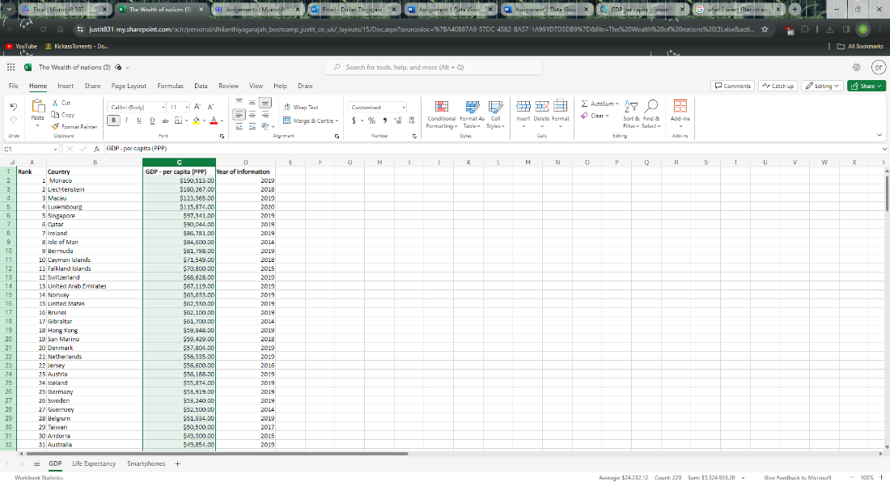

Then I clicked the expand icon next to Number tab in the Home menu. I set the Category to Currency, clicked £ from the Symbol drop down.

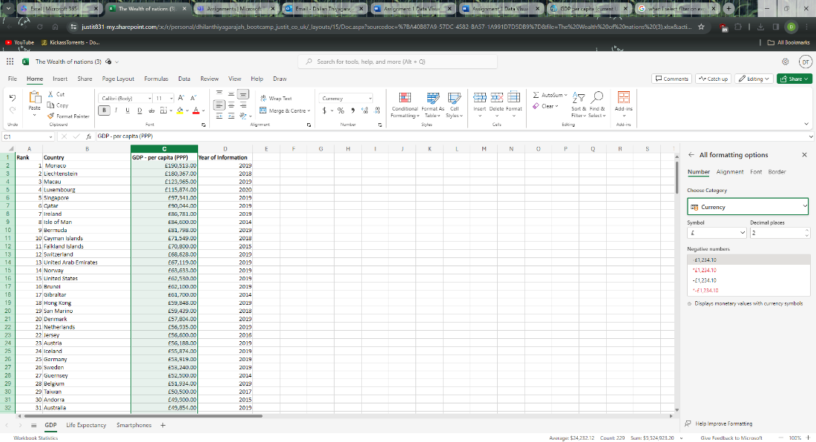

3) I clicked on a cell in the area I wanted to format into a table. Under the Home menu I selected Format as Table and chose an appropriate layout.

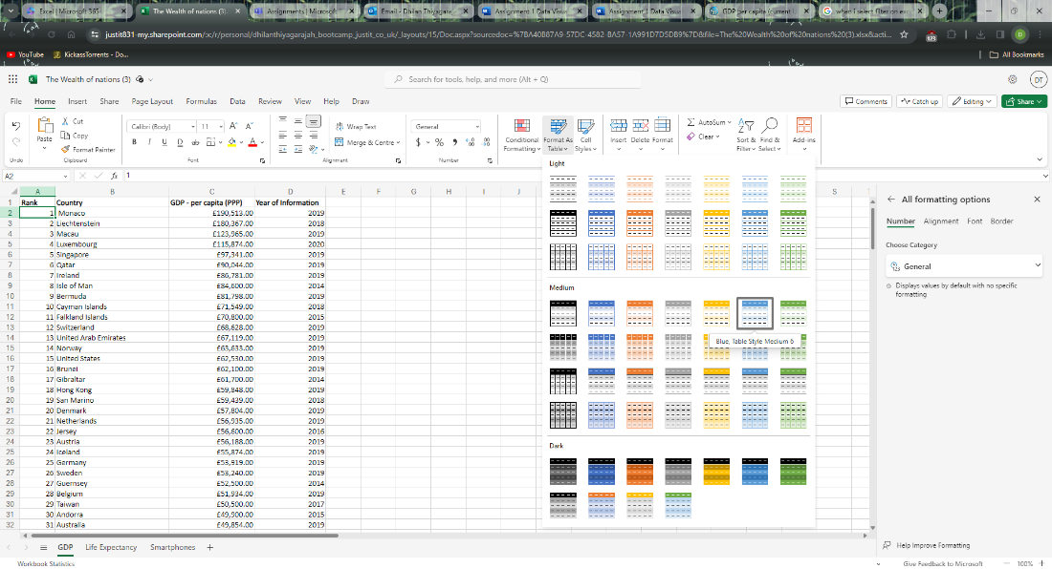

I confirmed what data range I wanted as a table.

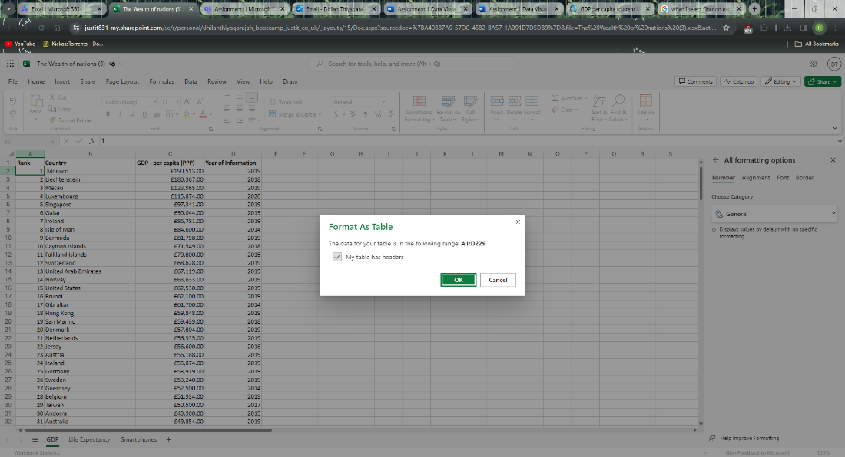

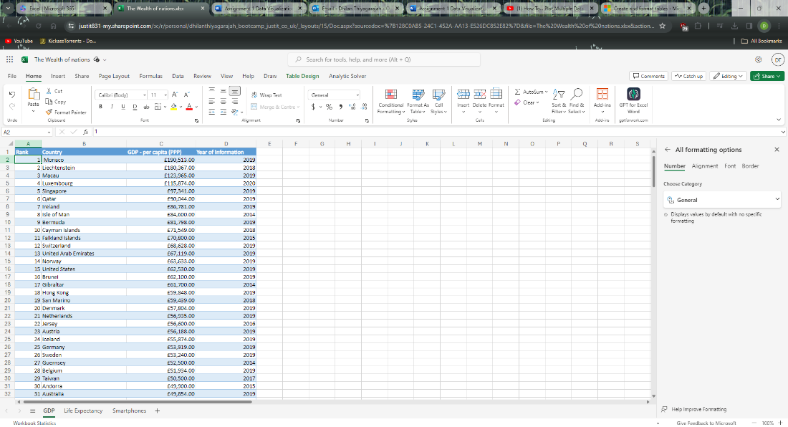

4)

To show only data from 2019 I initially clicked on the cell that had the Year of Information title. Then went to the Data menu tab and clicked on Filter. 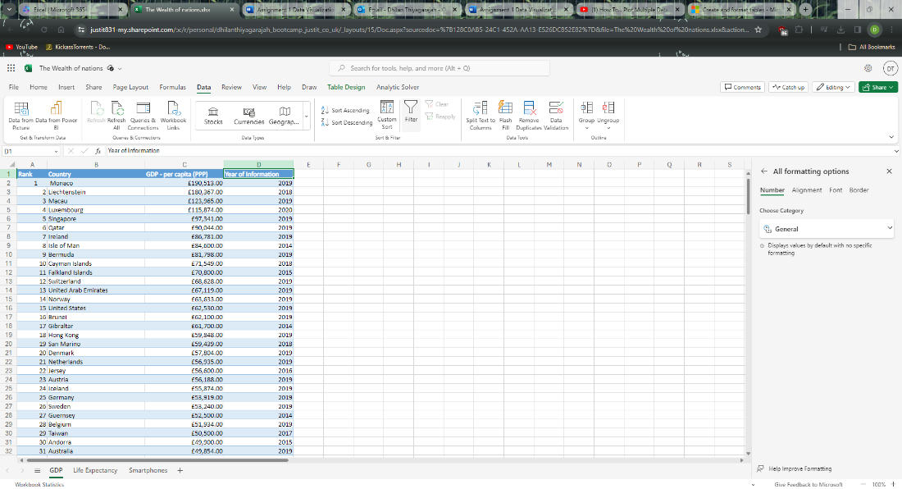

An arrow icon appeared next to Year. I clicked on that icon to see the sort and filter options. Here I deselected Select all, then searched for 2019 and selected the value to show only 2019 information.

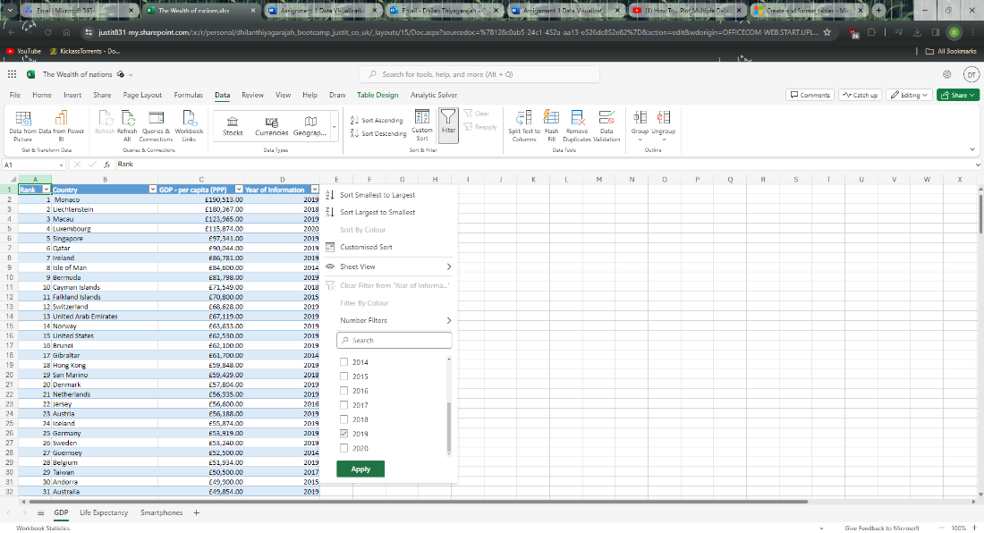

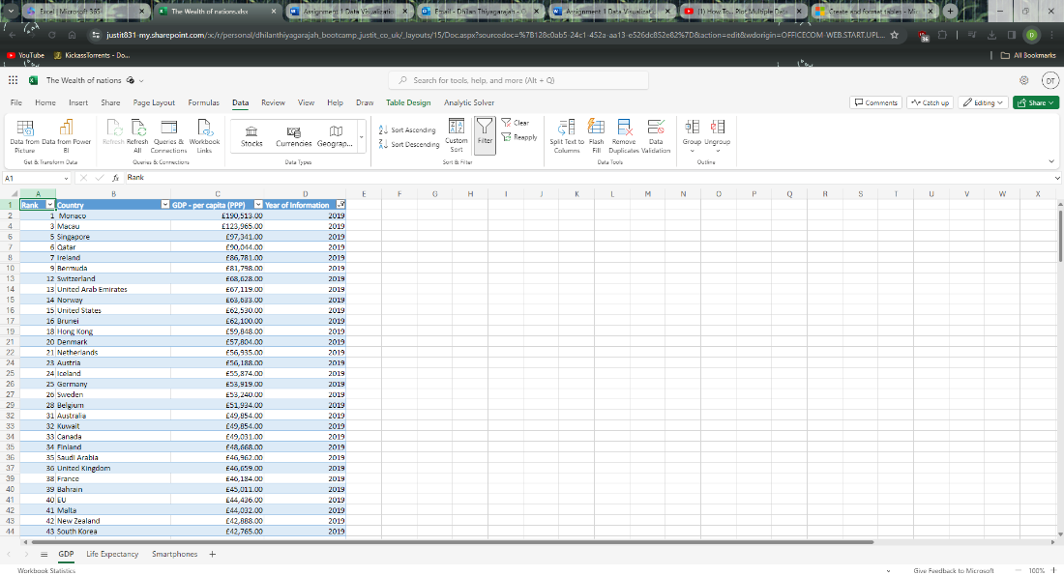

5)

To create a chart first I selected all data except the 2019 column as it has been already sorted.

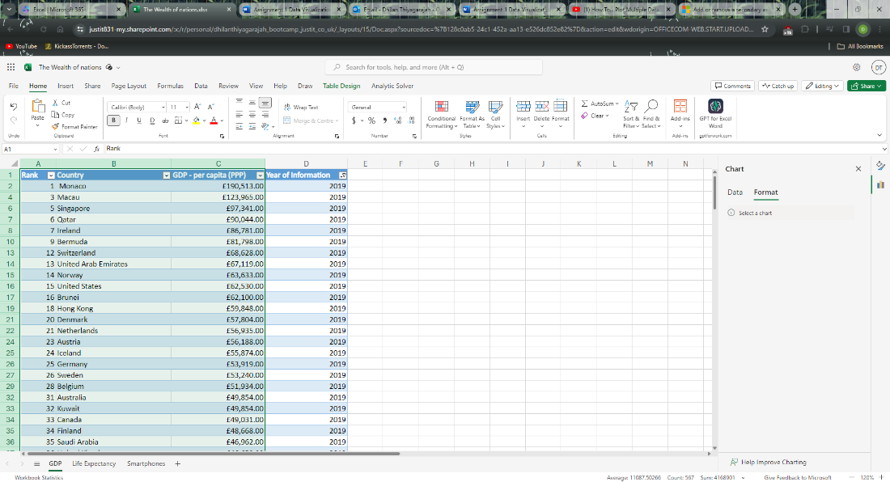

I then went to Insert and picked 2-D Bar

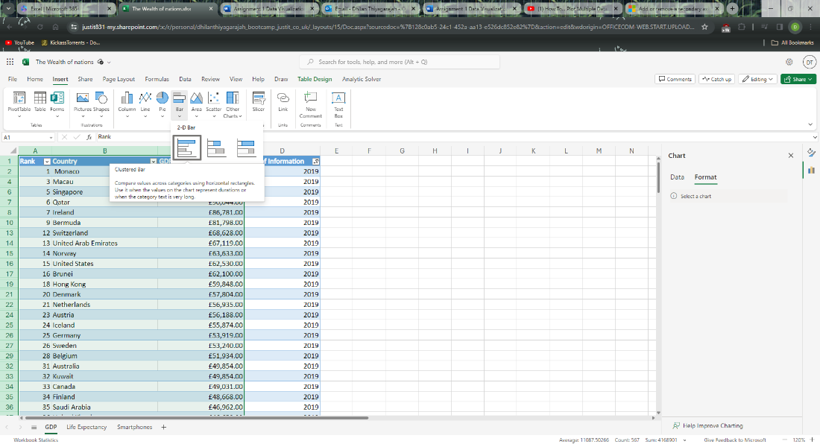

A Bar graph was generated with a title and legend.

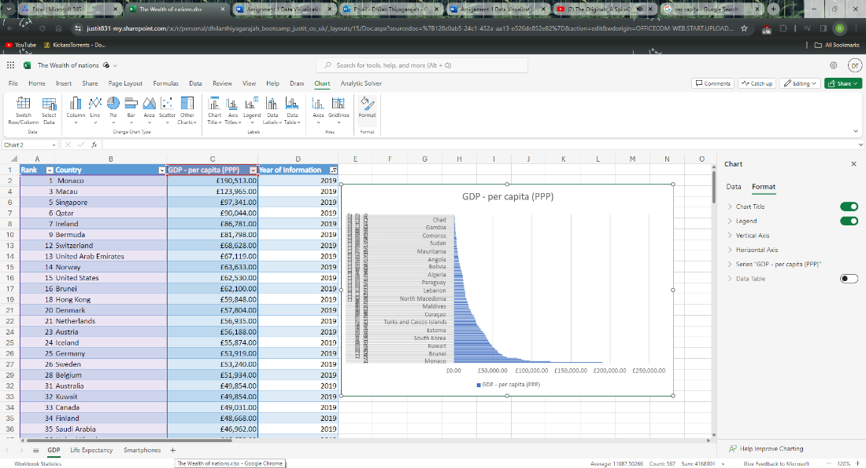

6)

a)

To add a title, I right clicked the chart and selected Format. Then under the Chart Title section there is a text box for Chart Title where I amended it to show Ranking of Countries based on GDP per Capita.

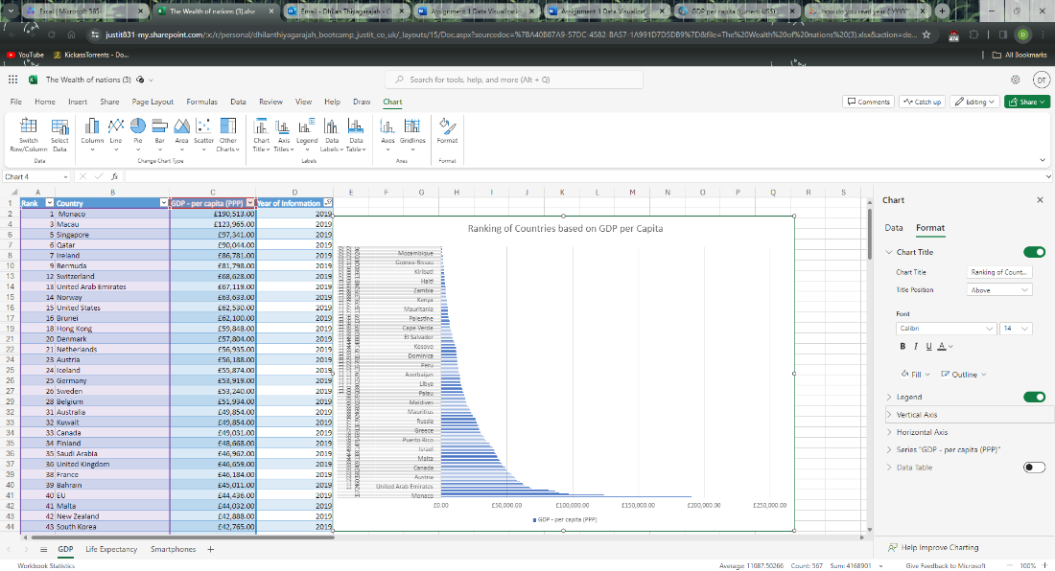

b)

In Format menu under Vertical Axis I clicked the Axis Title slide and text box next to Axis Title to “Countries by Rank”.

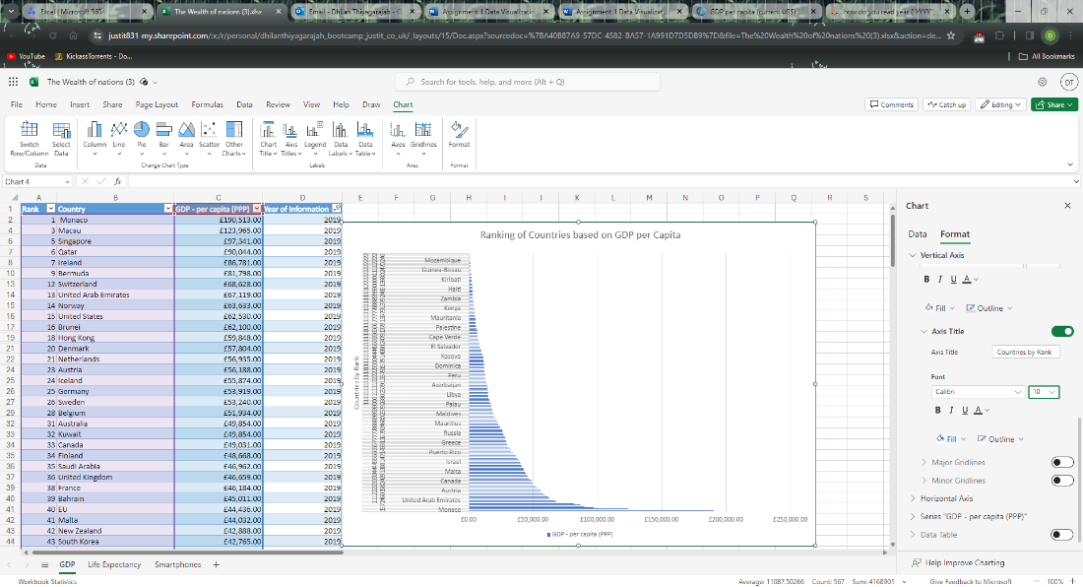

I then went to Horizontal Axis clicked on the Axis Title slide and edited the text box to “GDP per Capita (PPP)” in £.

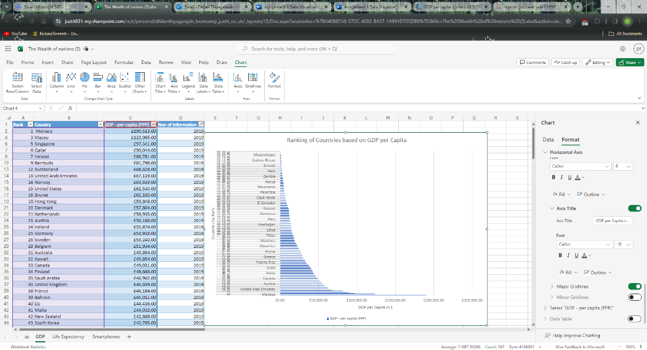

c)

To make it more presentable, I adjusted the font size of the axis titles to 12 and chart title to 16 as well as making the characters bold. I then went to the Horizontal axis and changed the Maximum Bounds to 200,000 and ‘Major Units to 50,000. I also removed the legend as only one continuous variable was being analysed.

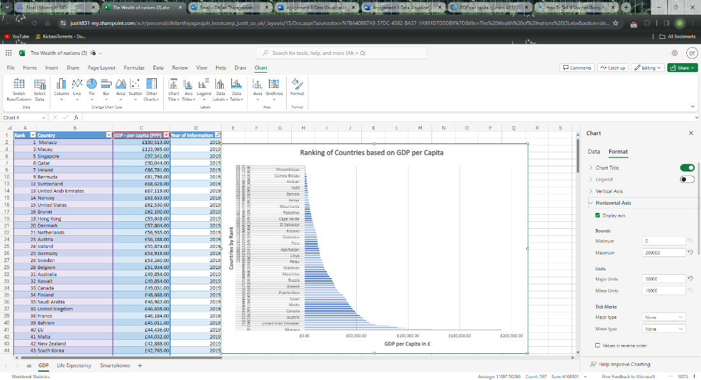

7)

I moved the chart to a new sheet by right clicking on the chart and selecting cut.

Then I clicked the plus sign at the bottom next to Smartphones sheet to create a new spreadsheet and pasted the chart.

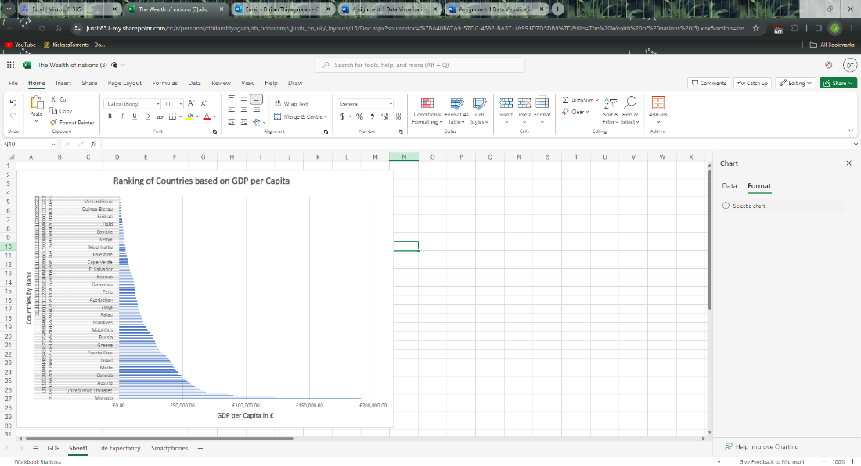

Double clicked on Sheet 1 tab to rename it to “GDP by Country”

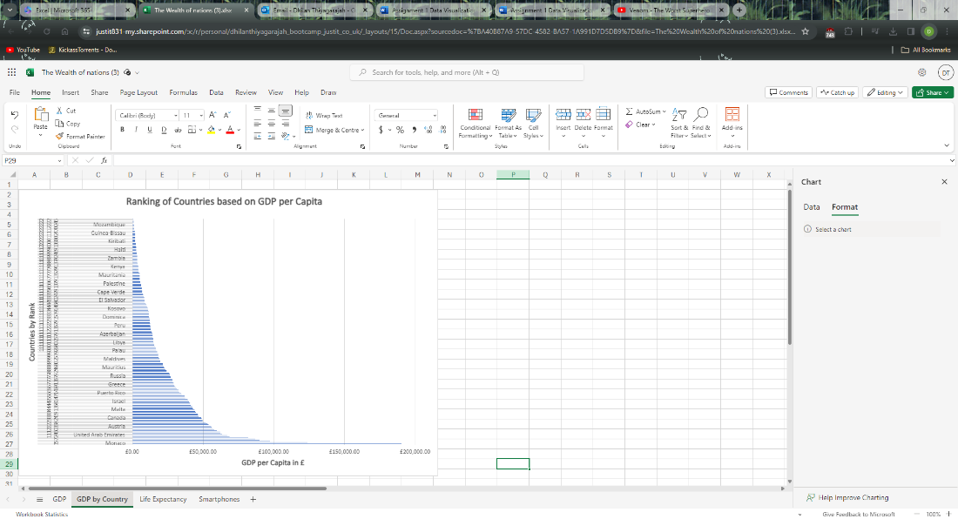

8)

Back on the GDP sheet, next to GDP per Capita (PPP) I clicked on the filter arrow and select Number filter, then top 10.

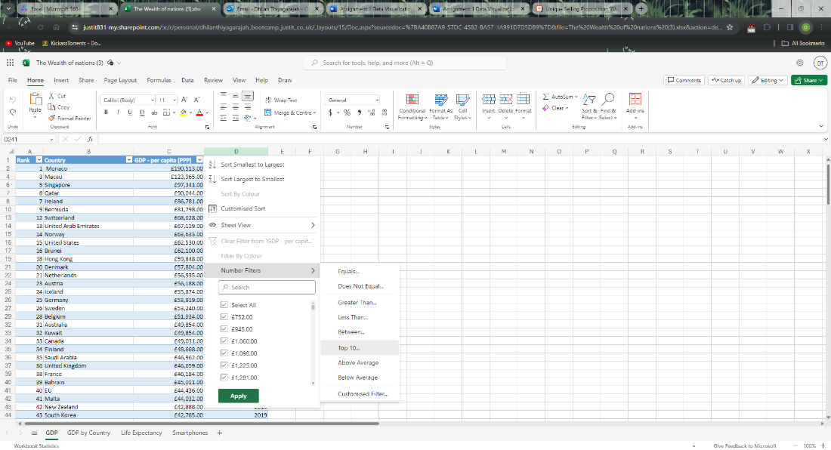

I then changed value to 20 as I want the top 20 ranked countries based on their GDP.

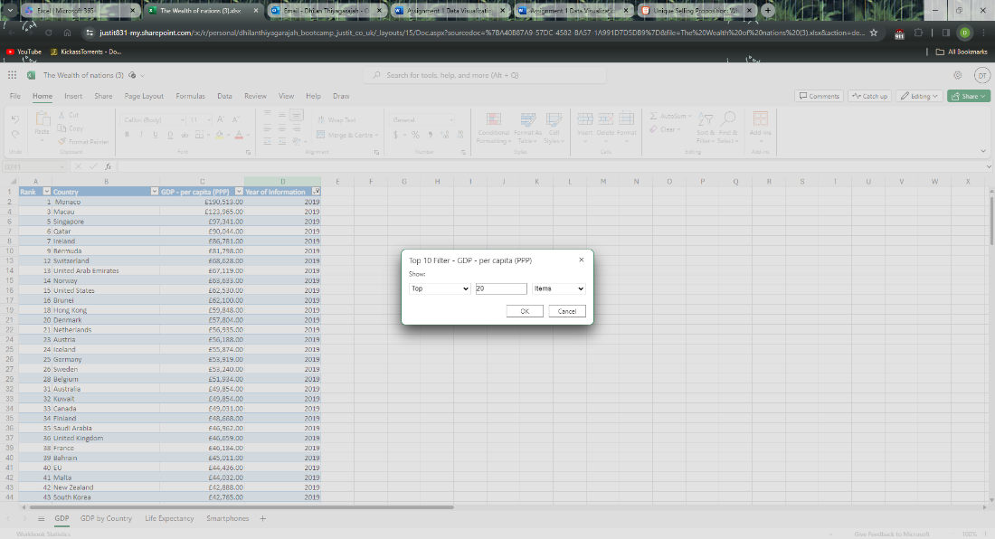

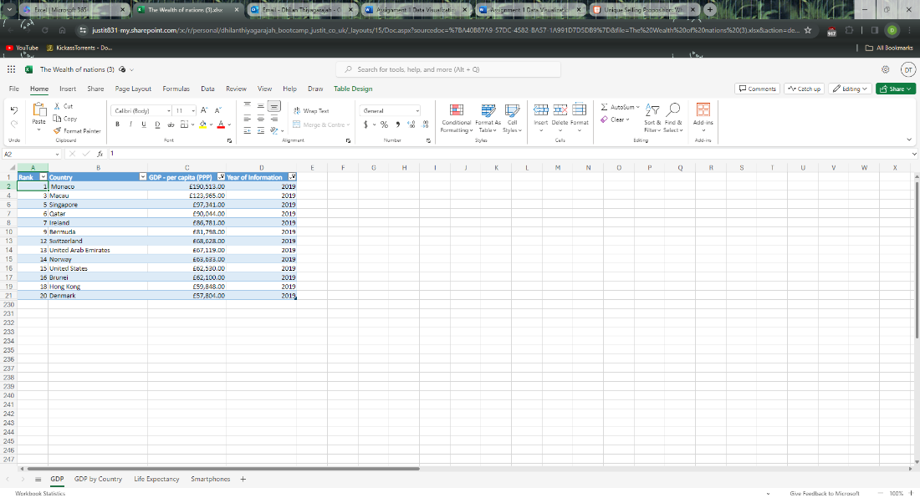

9)

To generate a bar graph, I highlighted everything other than Year of Information. Selected Insert, clicked on Bar and then selected 2D Bar.

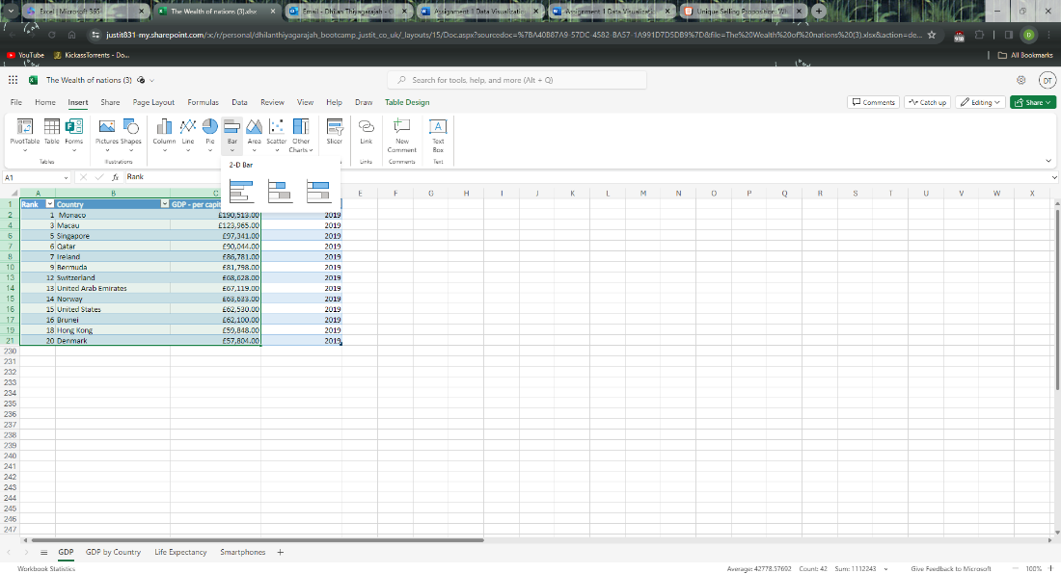

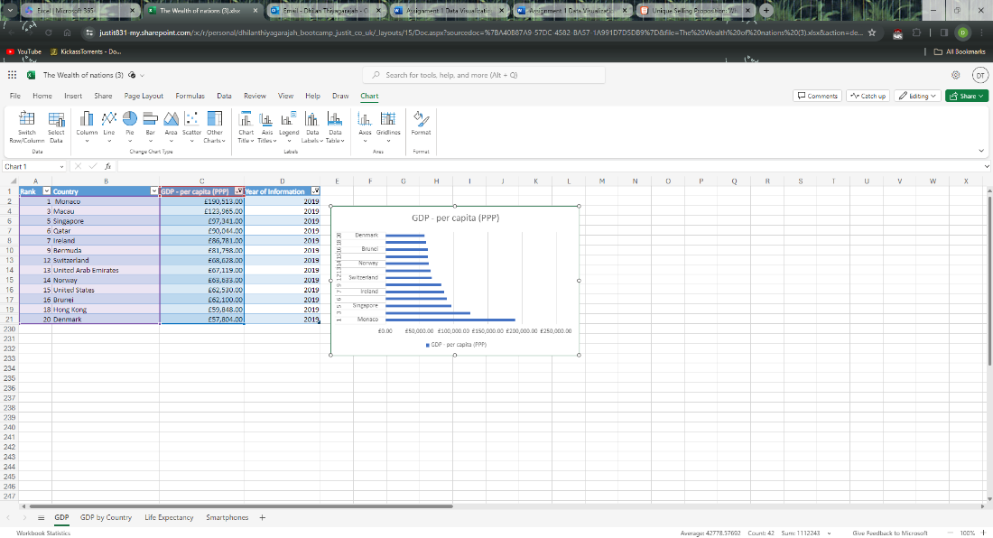

I then dragged the chart by holding left click on the graph and moving it below the table.

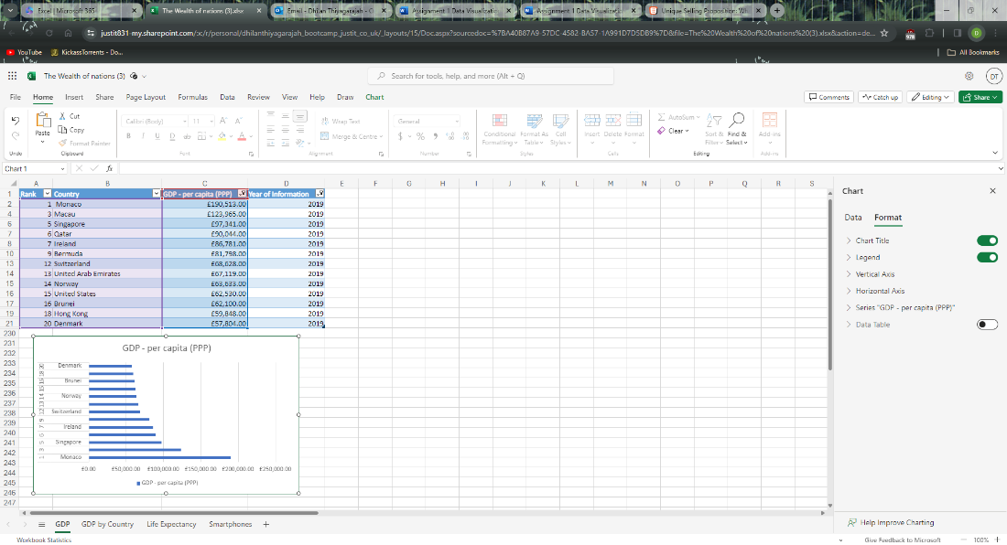

10)

I highlighted all the cells behind the table.

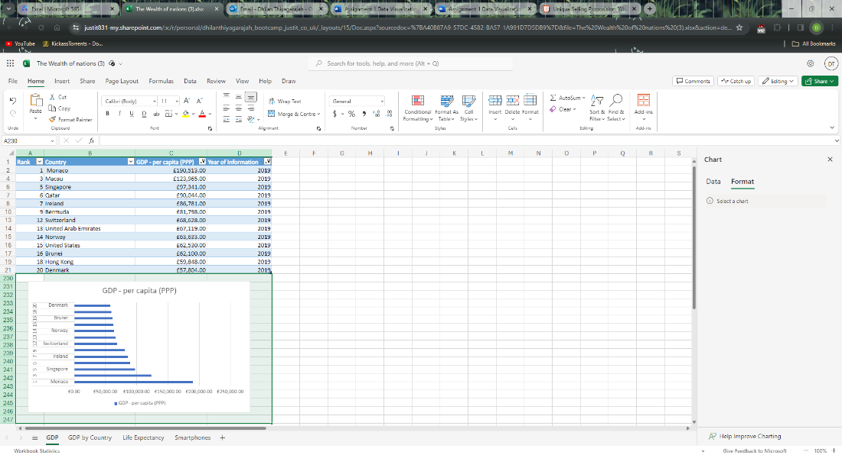

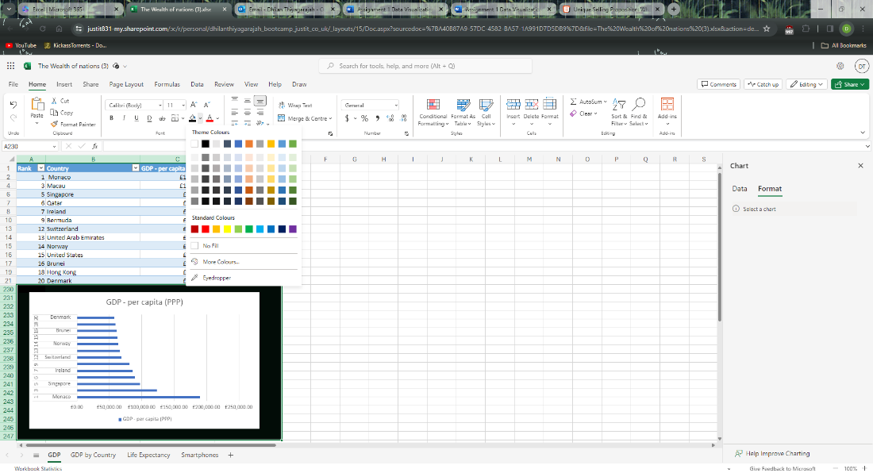

**Third Task:**

1)

To import an Excel spreadsheet on Tableau I clicked on Microsoft Excel on Connect to a file menu.

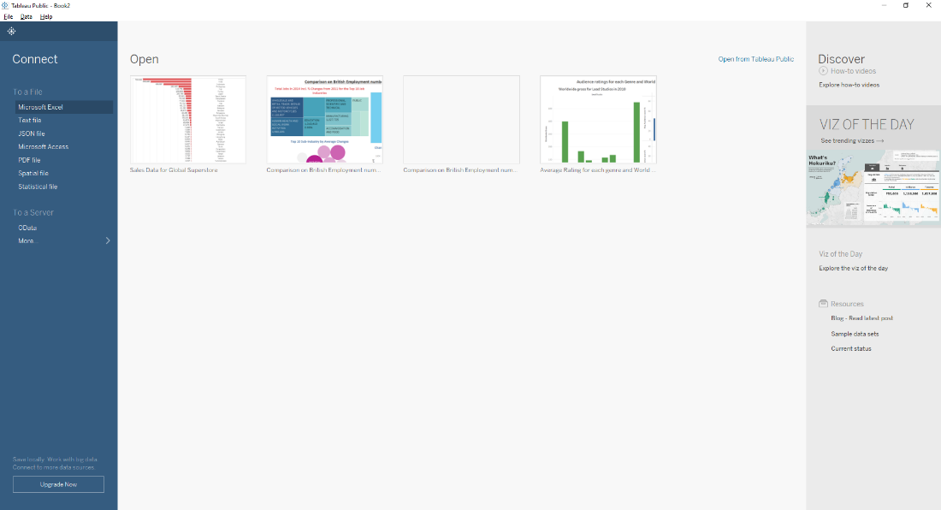

I selected the ‘The Wealth of nations’ file and clicked open

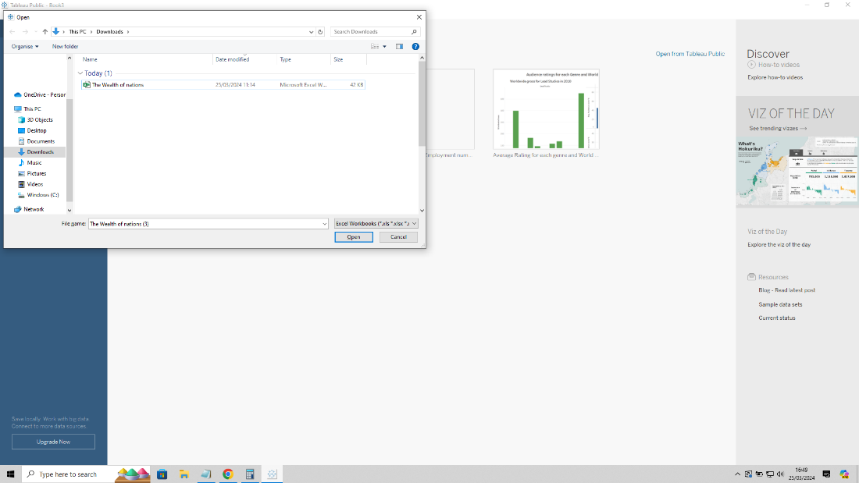

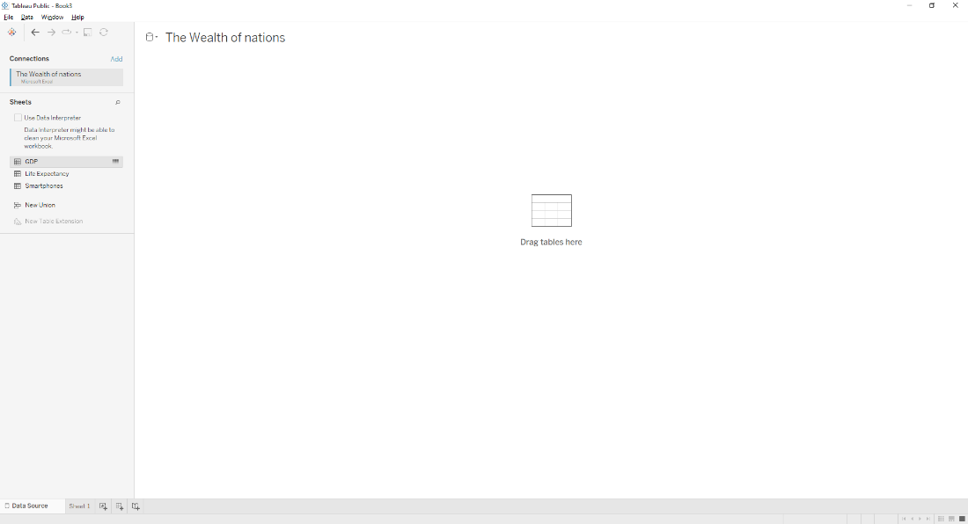

2)

I started by dragging and dropping the “GDP” tile and then did the same for “Life Expectancy”. A red exclamation symbol appeared as I needed to set the relationship for country between both sheets.

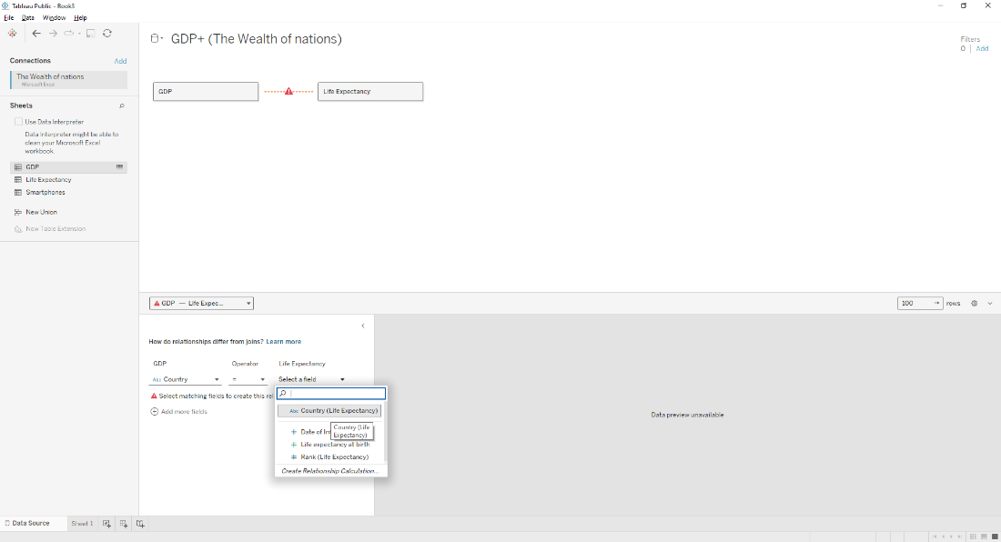

I had to do the same for “Smartphones” tile.

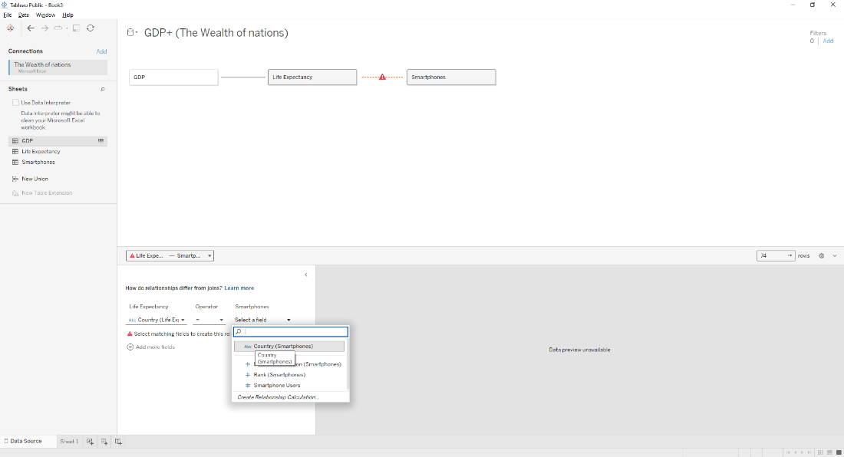

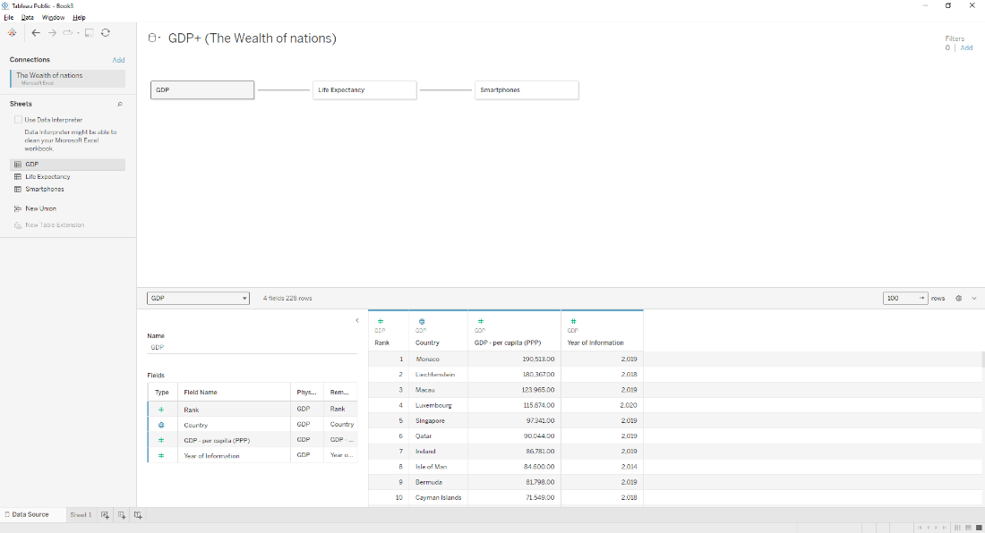

3)

Checking the data involves me correcting any data types and making sure they make sense.

In the table I can see that the Year and Date are in numerical (whole) data when it should be in date data. So, I changed the data type to date.

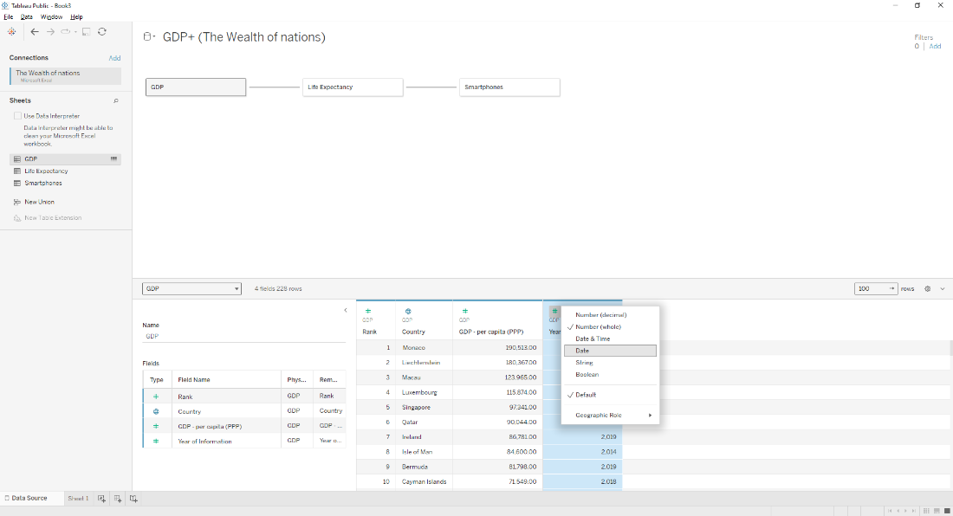

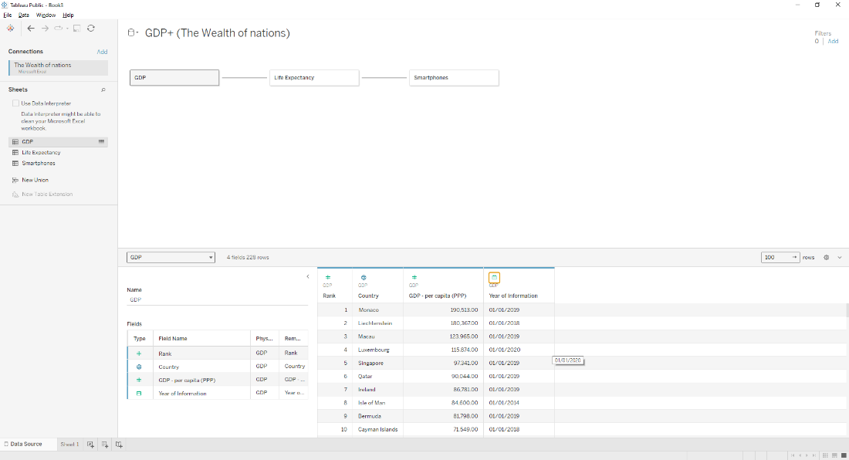

The dates are shown as “01/01/YEAR” which will be sorted out once I start creating visuals.

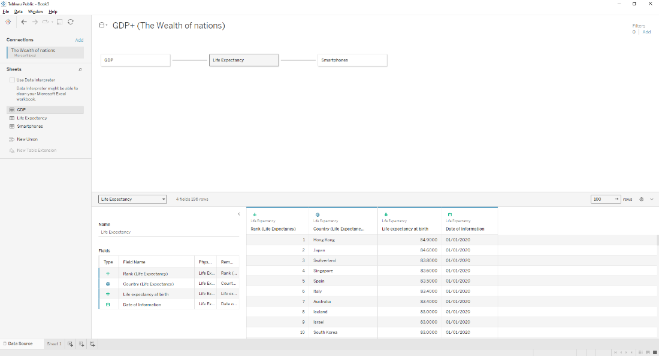

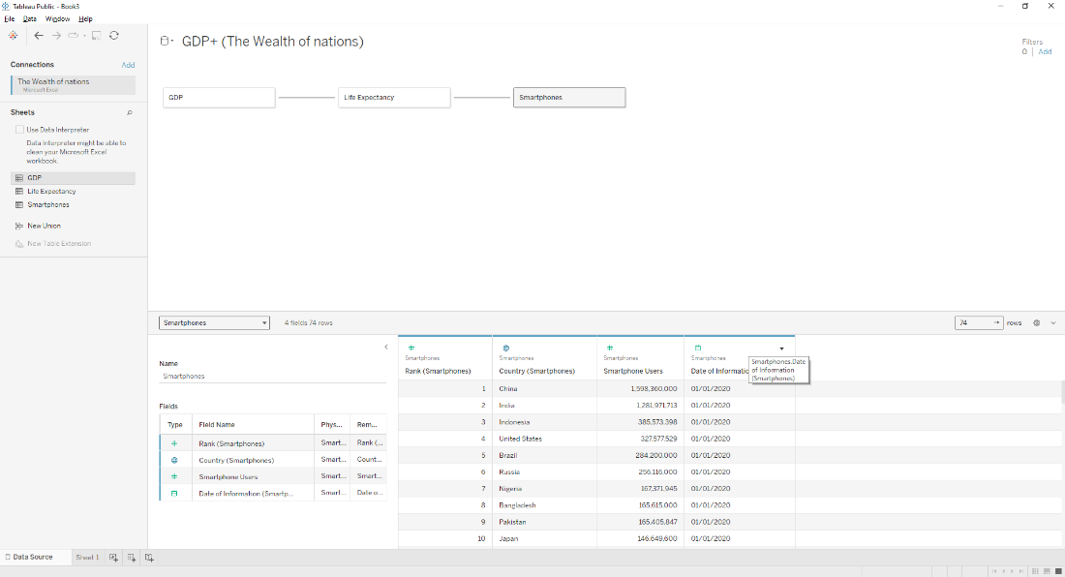

4) and 5)

**First chart:**

I wanted to create a chart comparing highest GDP per capita by country. I wanted the chart to look like an ordinary bar chart.

To start building charts I need to go to ‘Sheet 1’.

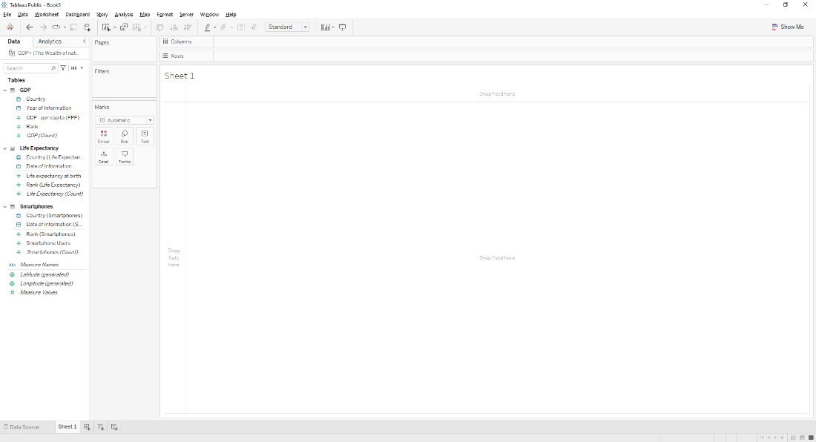

I dragged the discrete string ‘Country’ to column and continuous numerical ‘GDP per capita (PPP)’ to row areas. ‘GDP per capita (PPP)’ automatically shows up as SUM. I also wanted it to be in bar graph form, so I kept it as that.

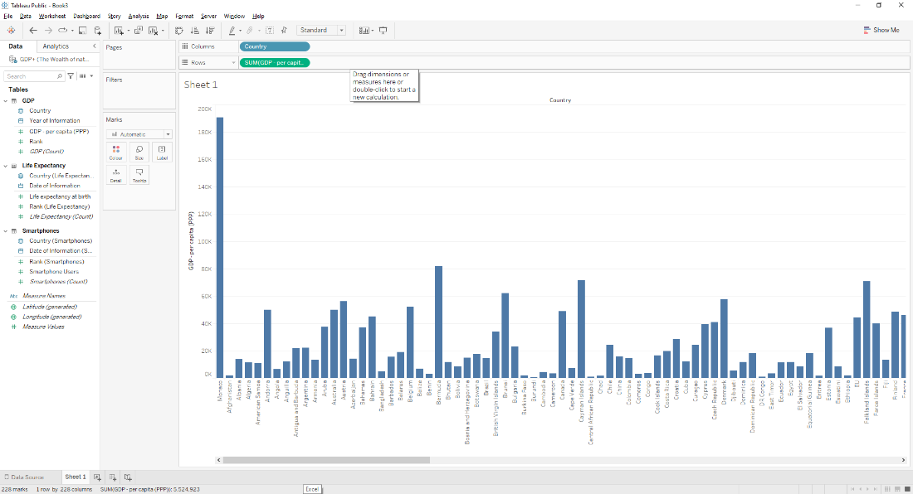

As the client only wanted the top 20 countries, I must apply a filter to reflect that. So I dragged discrete numerical ‘Rank’ to the Filter. As I did so field filters menu appeared and I selected Average.

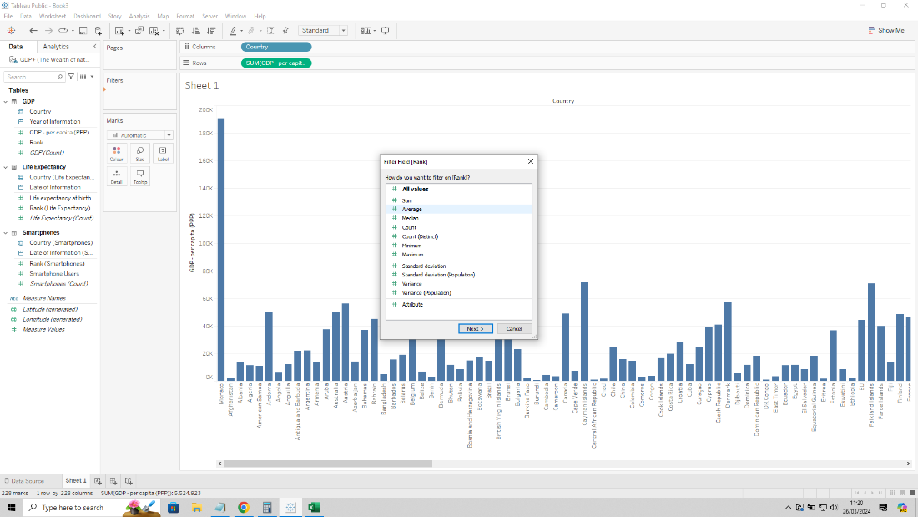

I then entered the range of values from 1 to 20.

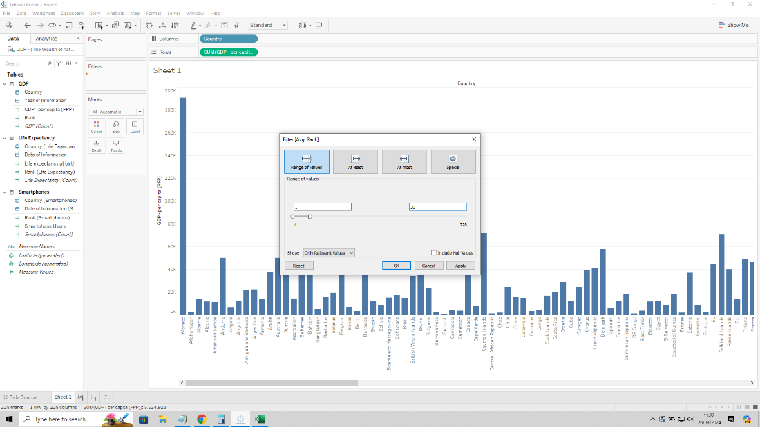

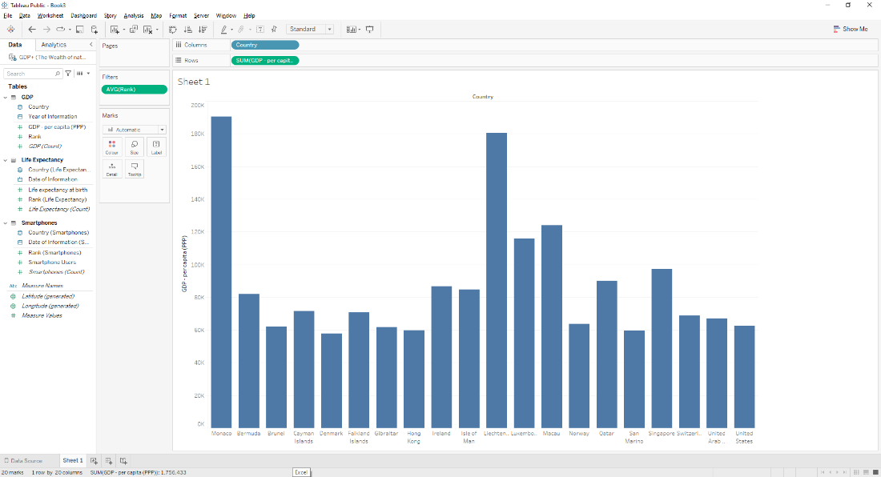

I then clicked on sorted descending icon to sort out the bars to follow the rank.

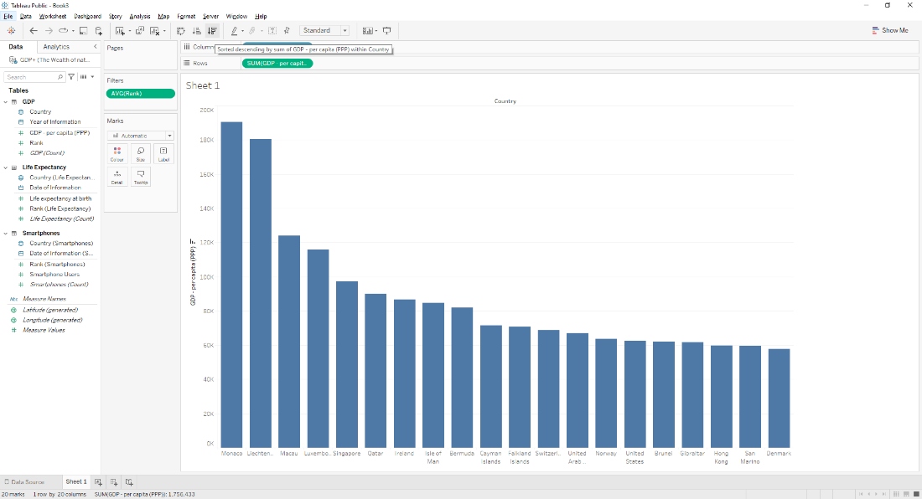

I wanted discrete date ‘Year of Information’ displayed on the graph with the ‘GDP per capita (PPP)’ as it was relevant to see when the data was measured. I dragged both to the Label legend in the Marks tile. ‘Year of information’ automatically converts to ‘YEARS’ function. 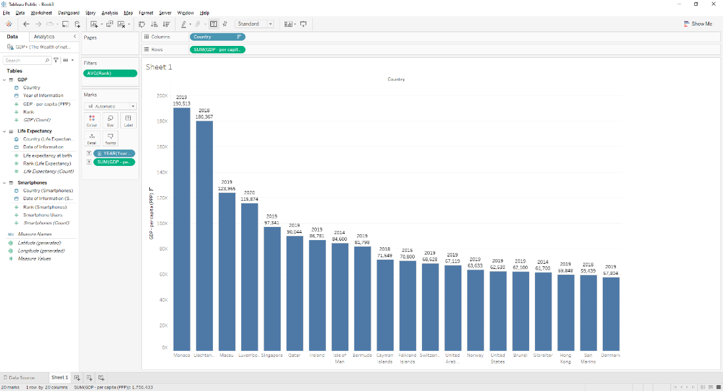

I wanted to show a colour gradient for my bars, so I dragged ‘GDP per Capita (PPP)’ to the Colour legend in Marks tile. As the client is colourblind I had to stick to shades of blue and orange.

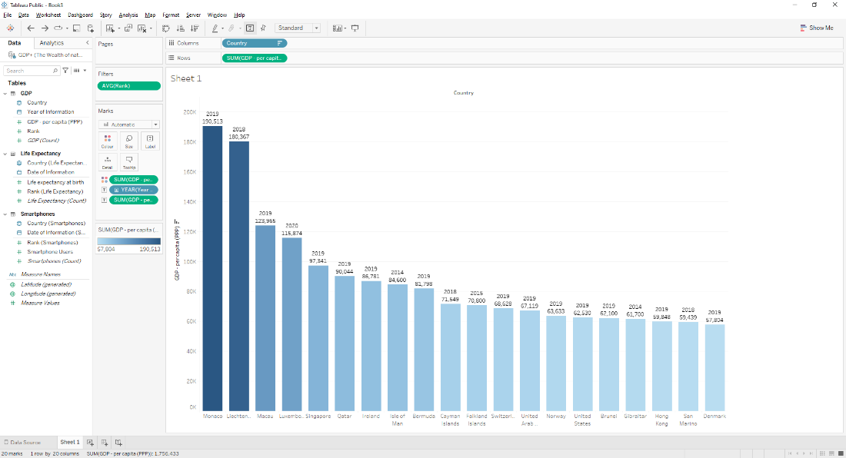

I switched the rows and columns to make it easier to compare by clicking on

I then generated a title for the chart by clicking on the ‘Sheet 1’ title at the top and editing the text in the textbox, changing the bold, size and alignment.

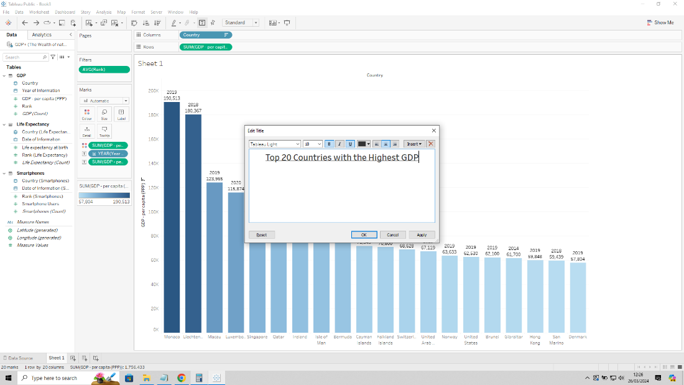

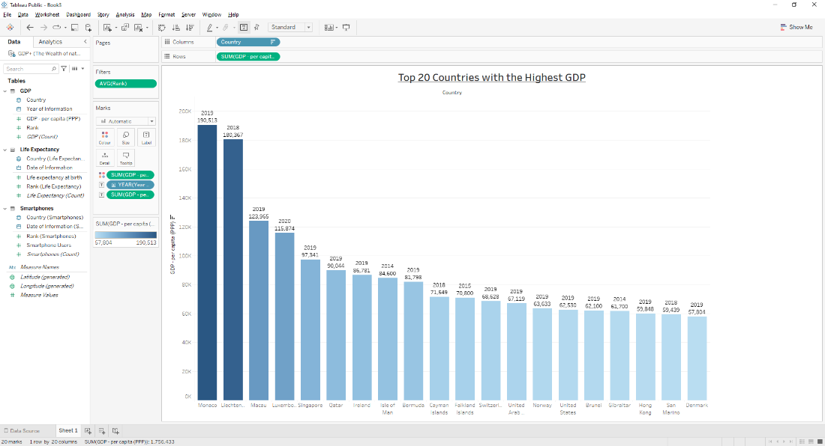

**Second Chart:**

I wanted to create a chart comparing highest life expectancy by country. I wanted the chart to look like a world map.

I started a new sheet by clicking on New Worksheet next to ‘Sheet 1’.

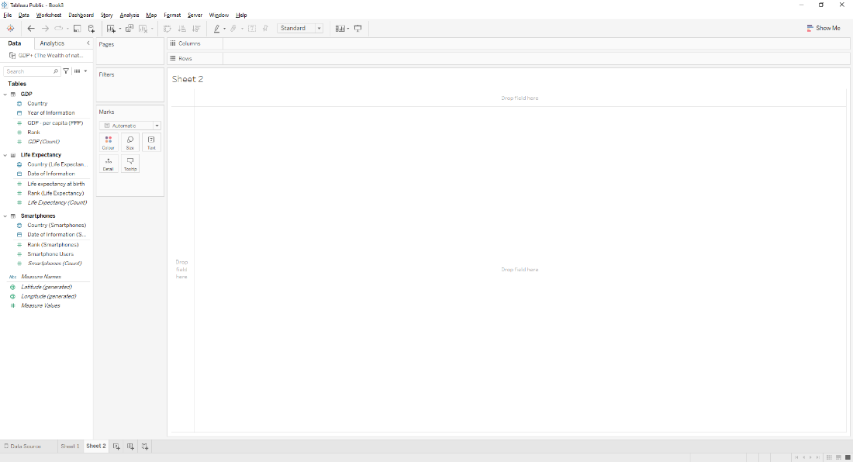

I dragged string ‘Country (Life Expectancy)’ to row and numerical ‘Life expectancy at birth’ to column. This generated a bar graph.

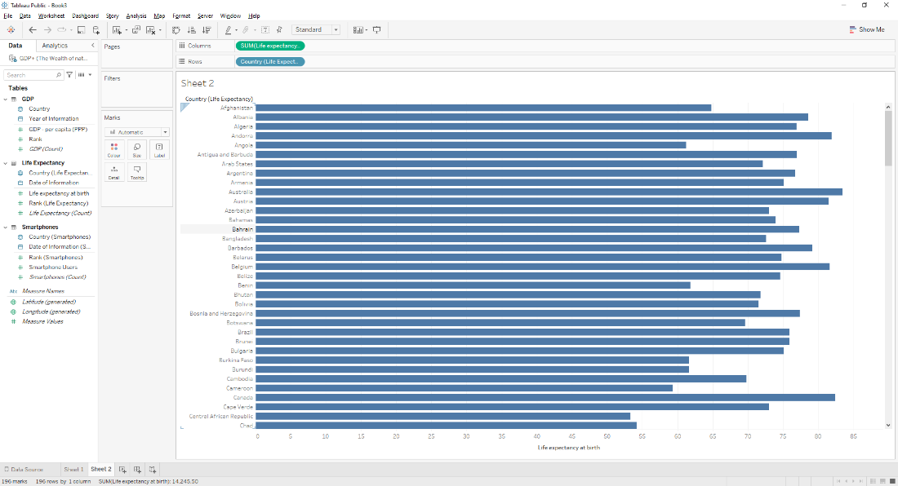

I went to Show Me menu and selected the ‘world map’.

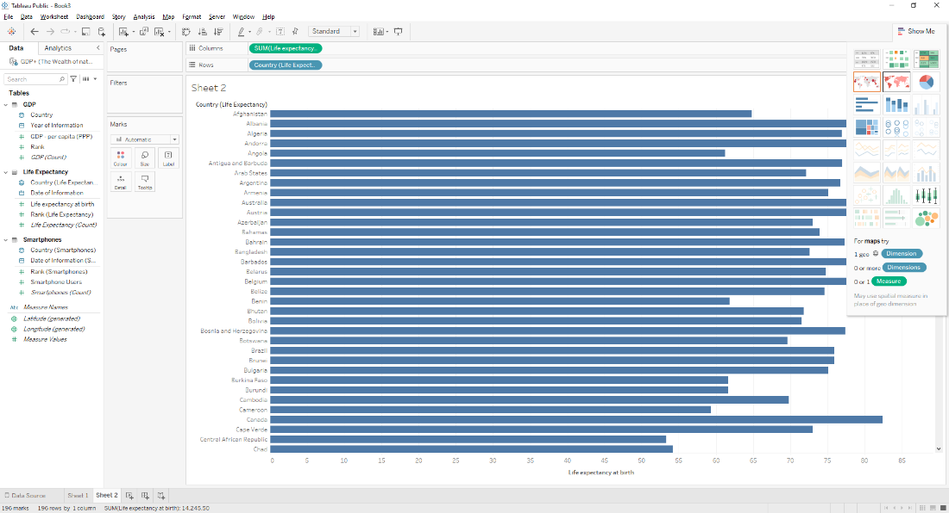

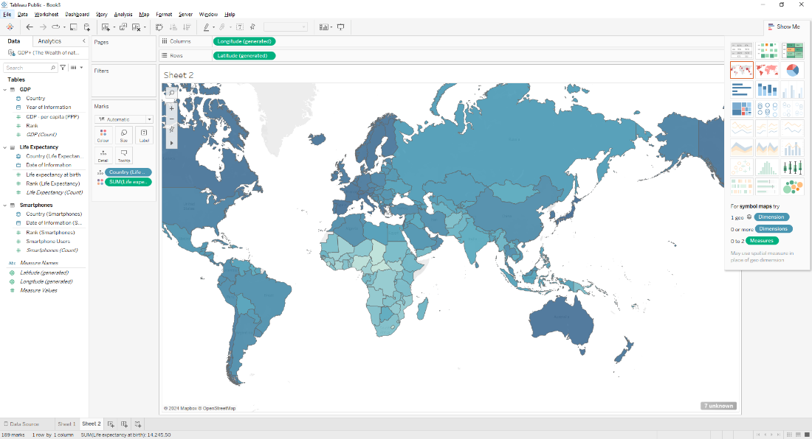

In order to give me top 20 countries I dragged numerical ‘Rank (Life Expectancy)’ and dropped in Filter. Filter option popped up so I clicked on Average and then changed to range to show 1 to 20.

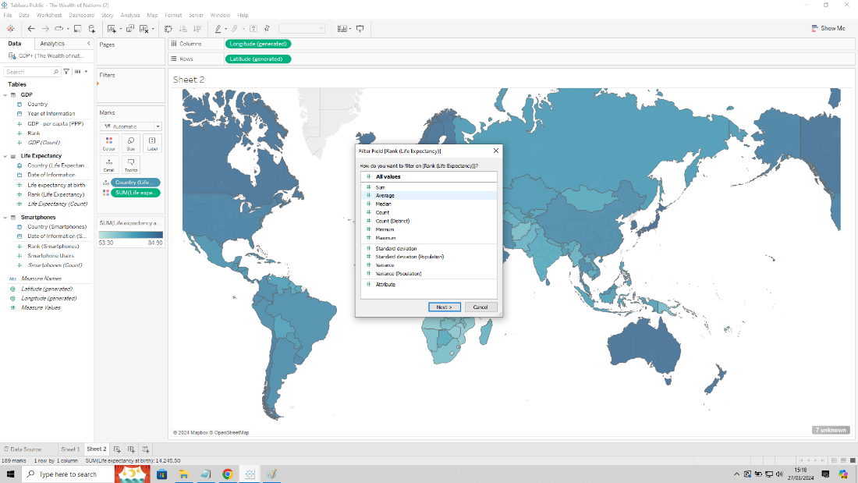

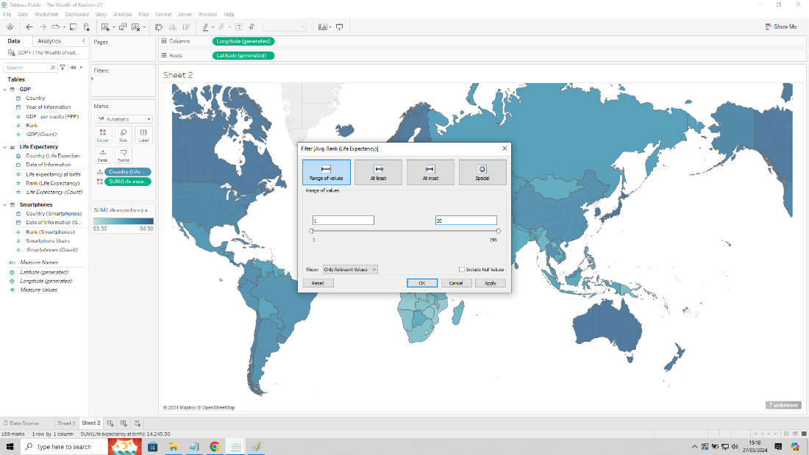

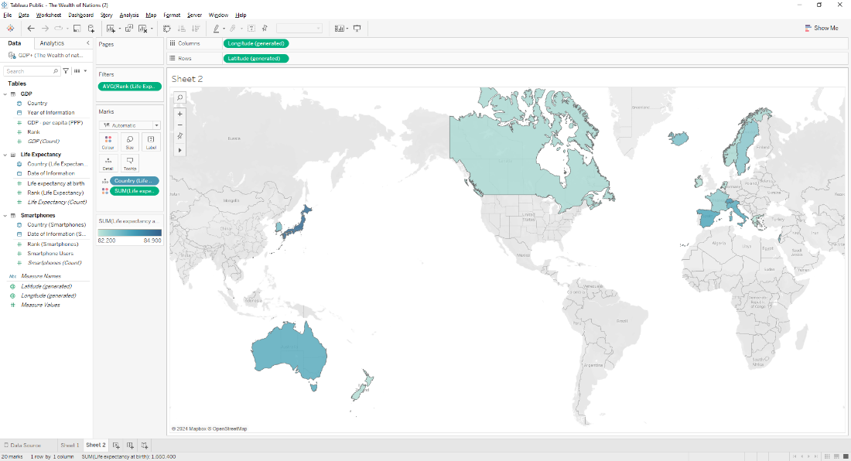

I kept the same shade of blue for the client. I went into Maps menu, Background Layout and then unticked Country/Region name to make it easier to look at.

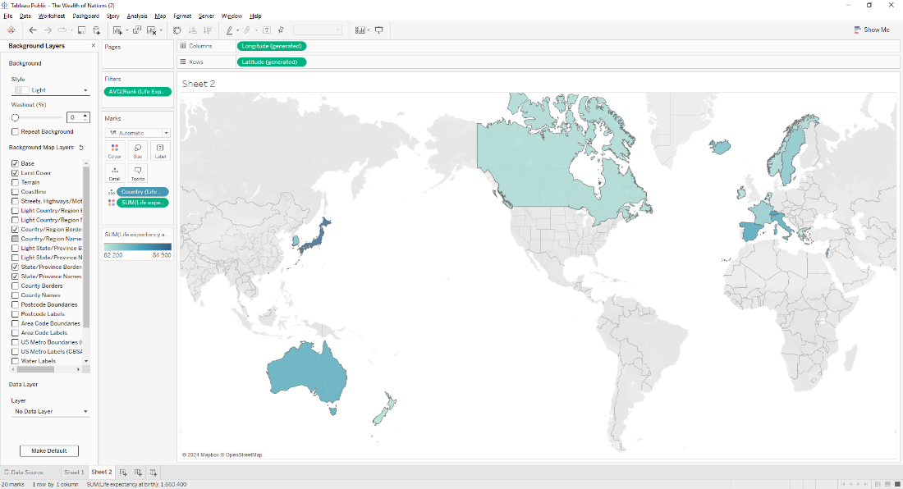

I dragged and dropped the date 'Date of Information’ into the Detail legend in Marks tile to show what year the information came from. It automatically converted to ‘YEARS’ function.

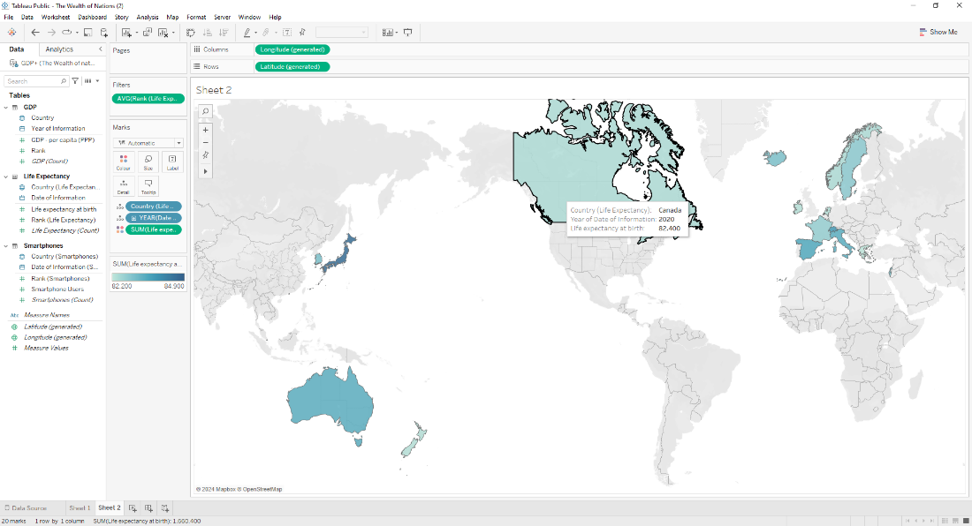

I then changed the title of the chart by clicking on the title area.

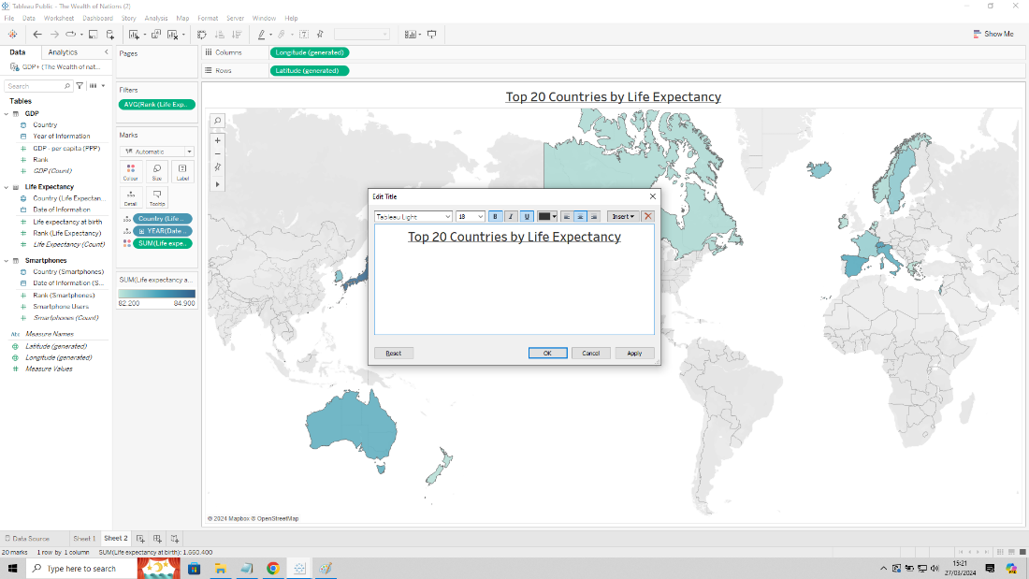

**Third Chart:**

I wanted to create a chart showing which countries had the highest smartphone users. I wanted the chart to look like a highlighted table.

I started a new sheet again and dragged and dropped string ‘Country (Smartphones)’ to Column and numerical ‘Smartphone Users’ to Row.

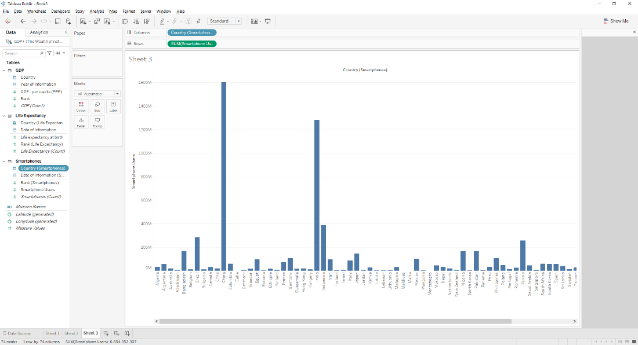

I then went to Show Me and clicked on ‘highlight tables’ to show it in table form.

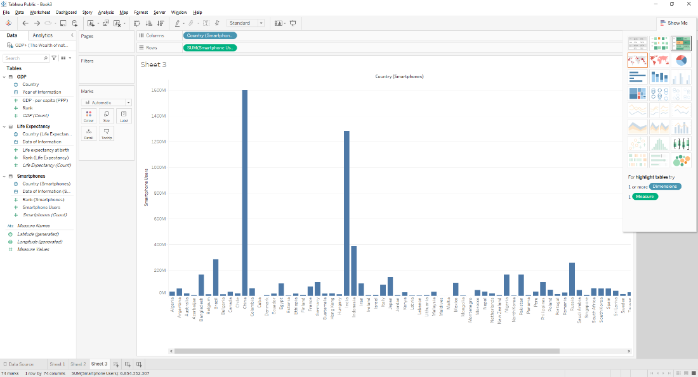

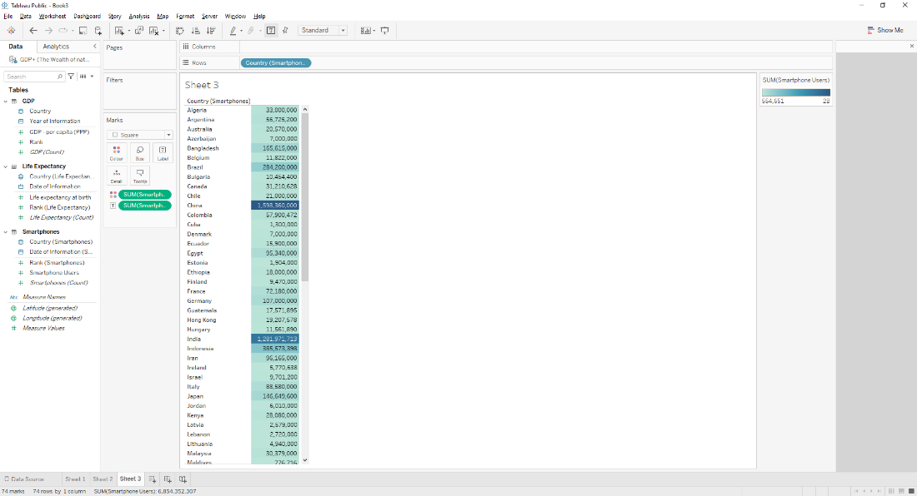

I then brought numerical ‘Rank (Smartphones)’ to Filters, selected Average and then changed the range values to 1 to 20.

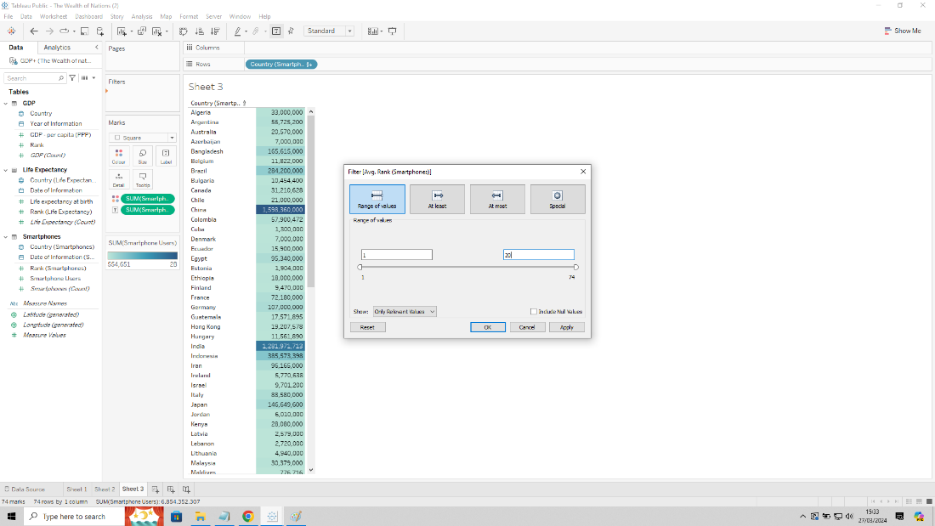

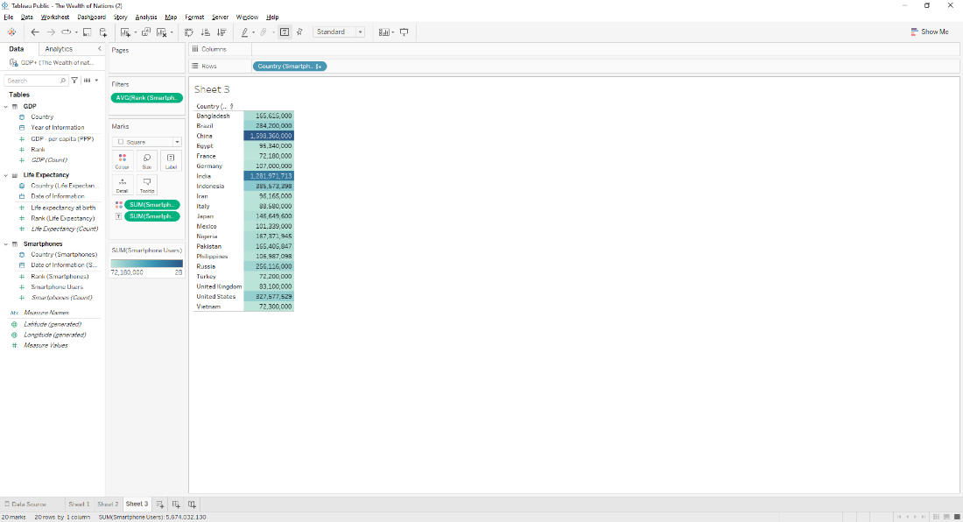

I sorted the table out in descending order by clicking the sort icon.

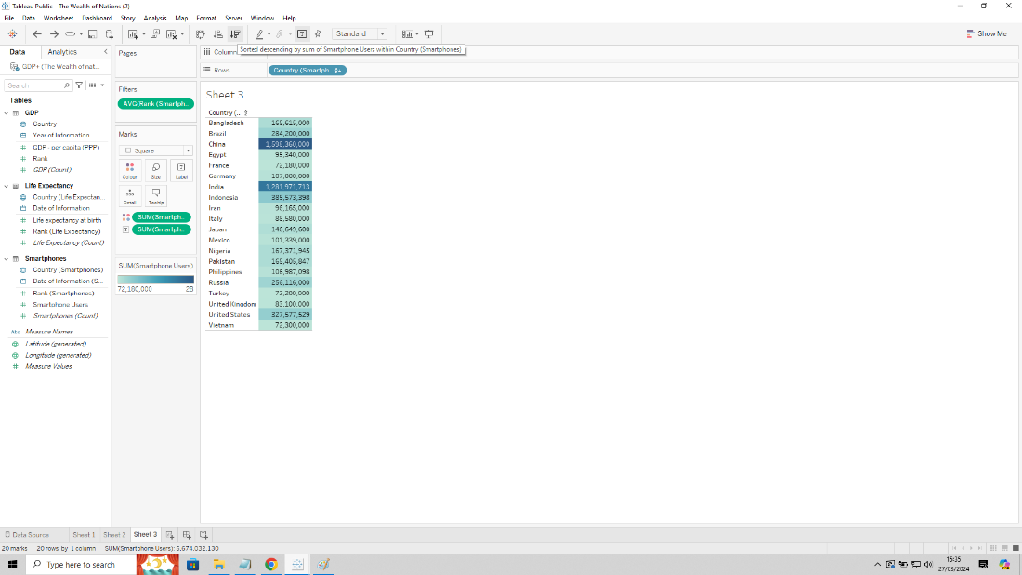

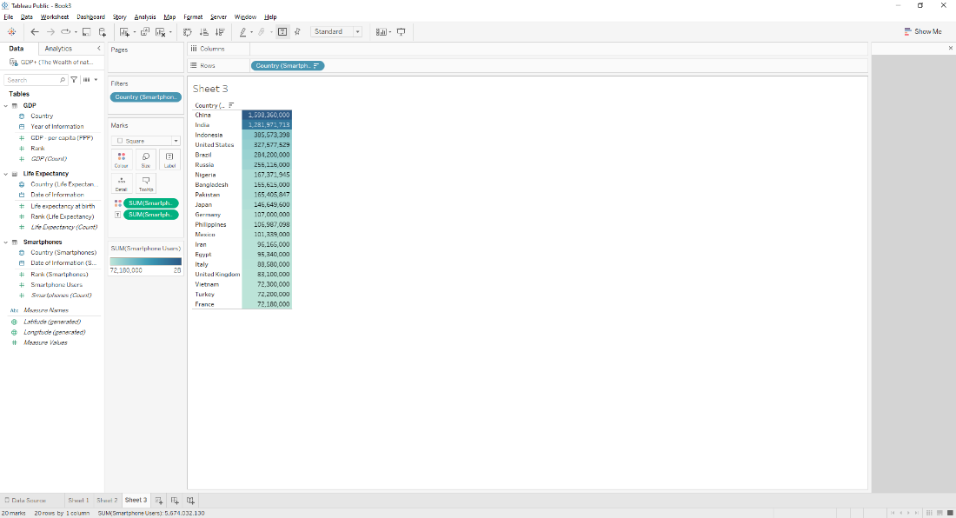

I then made the clicked on the title area to name the chart.

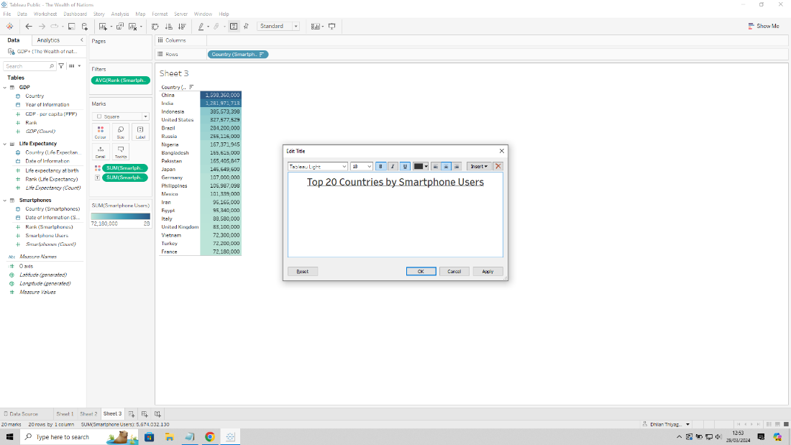

**Forth Chart:**

I wanted to compare both Smartphone users against the top 20 ranking countries by Life Expectancy including the GDP per Capita (PPP). I wanted the chart to look like a tree map.

I created a new sheet and drag and dropped numerical ‘Smartphone Users’ to Column and string ‘Country (Life Expectancy)’ to Row.

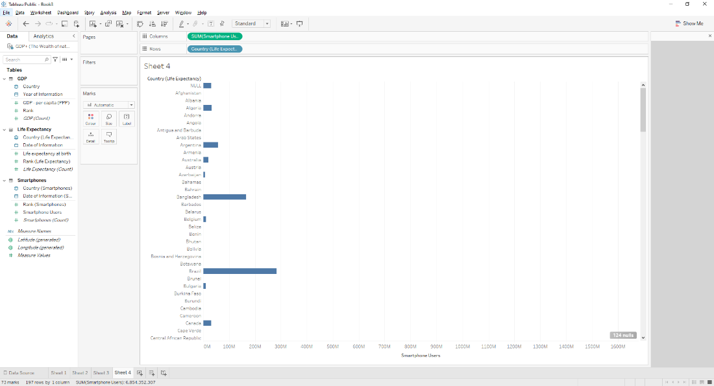

Next, I filtered out the countries that only representing the top 20 countries for Life expectancy. I dragged and dropped numerical ‘Rank (Life Expectancy)’ and selected Average on the Filter menu.

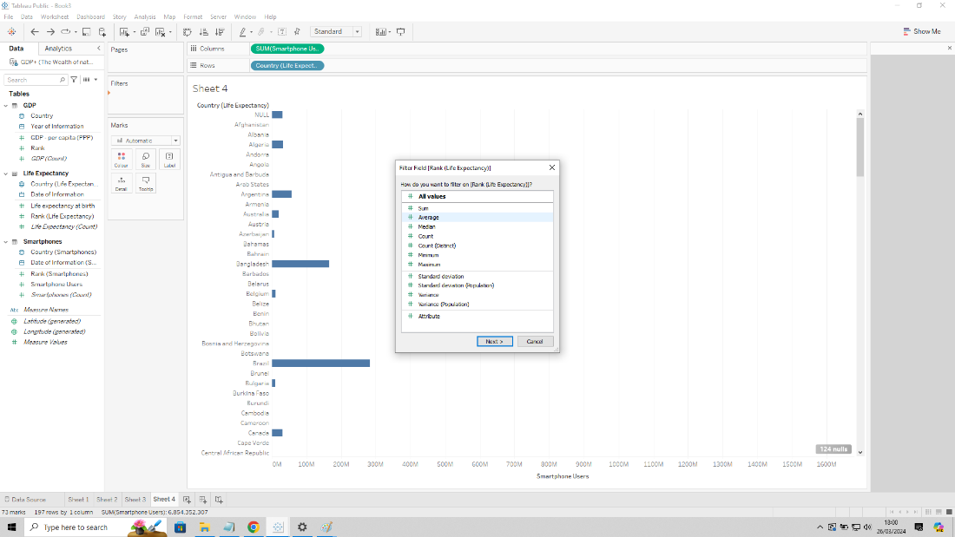

Changed the range to represent 1 to 20.

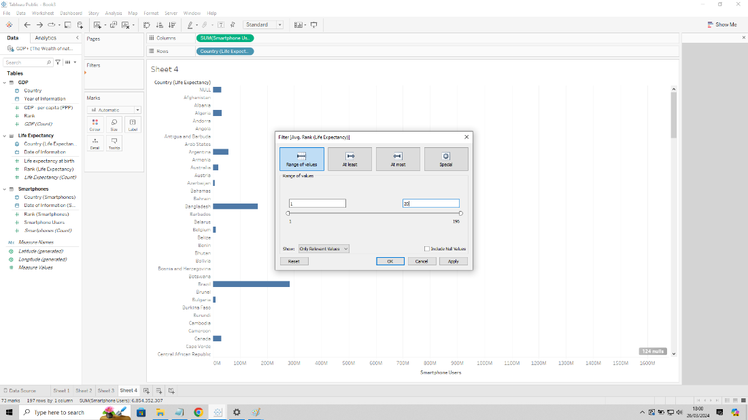

Then sorted in descending order by clicking the sort icon.

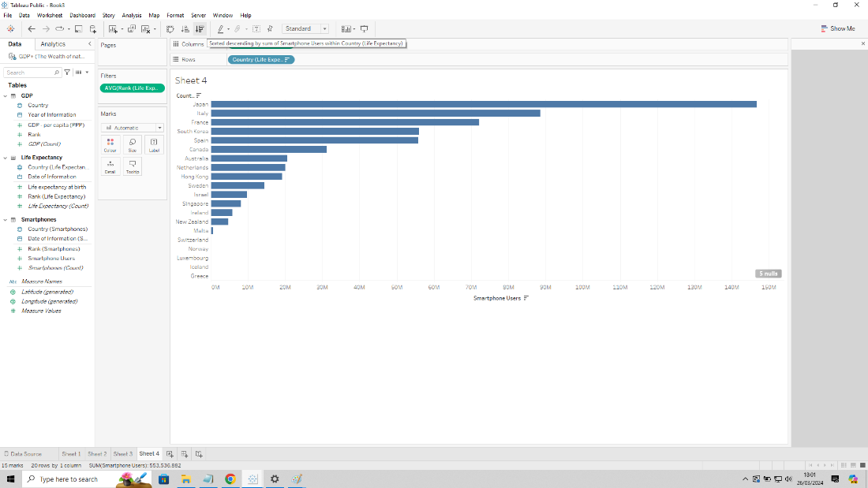

I then clicked on the grey box that says 5 nulls and clicked Filter data to remove any null values.

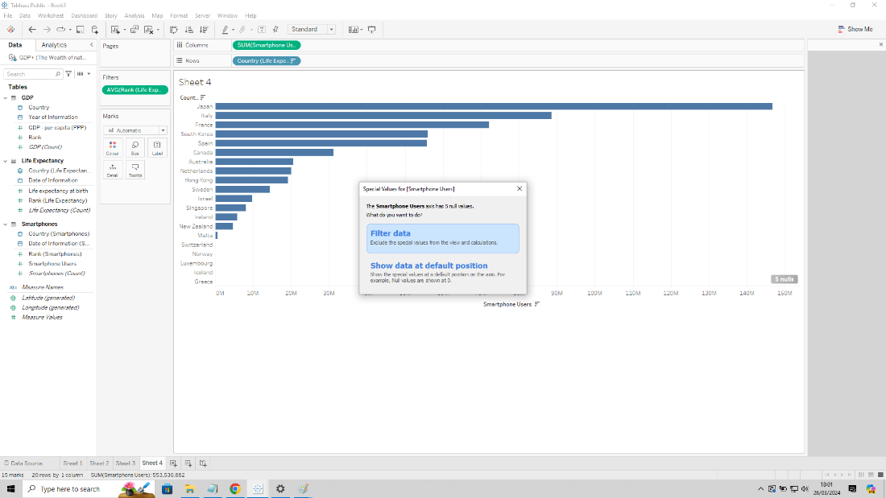

I went to Show Me and selected ‘tree maps’ to generate the tree map chart.

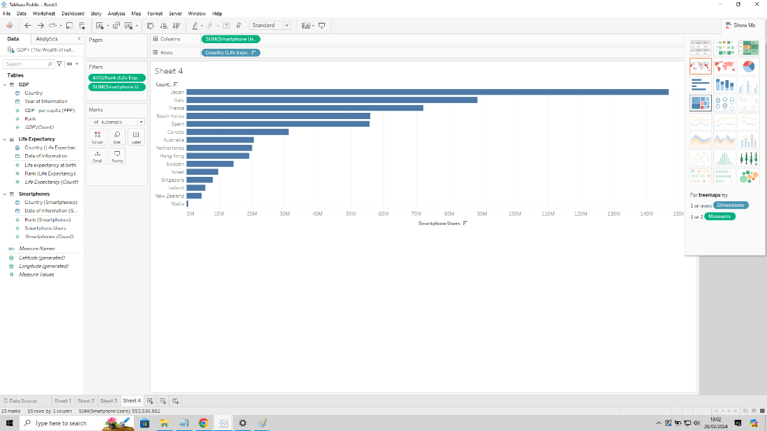

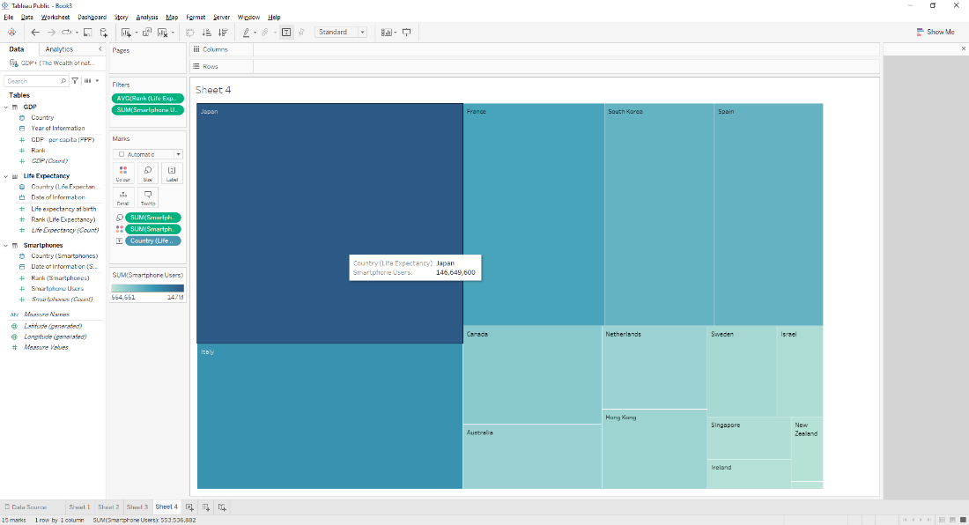

I then dragged and dropped numerical ‘GDP per capita (PPP)’ to Details legend on the Marks tile so I can also show GDP data.

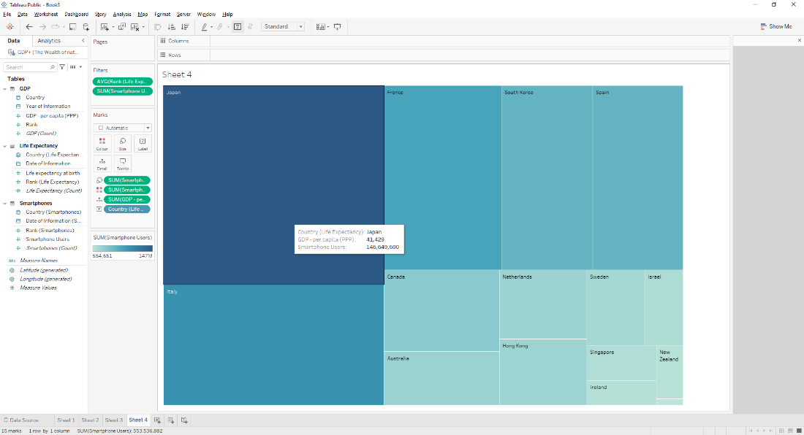

I decided to turn the chart orange by clicking on the colour gradient tile.

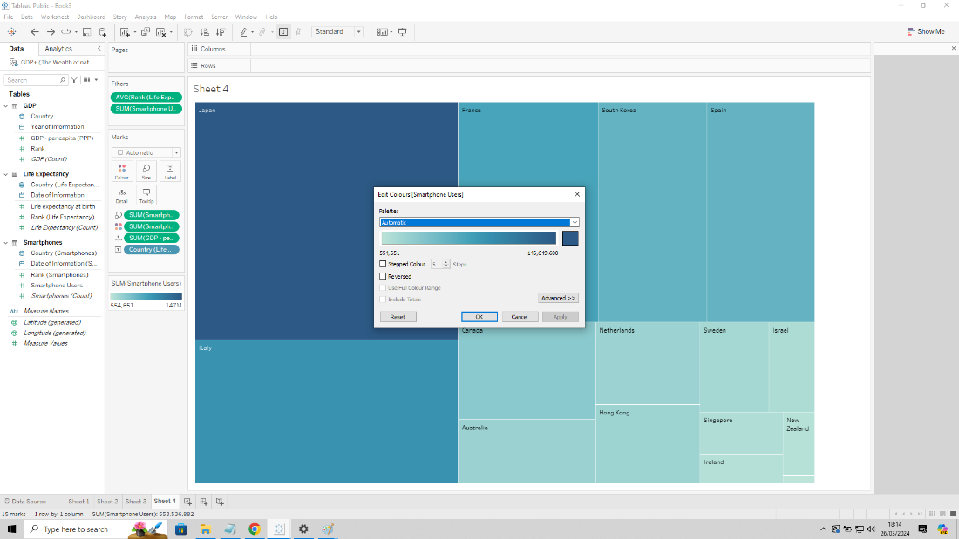

I then clicked on the blue square and chose an appropriate orange to use then clicked apply.

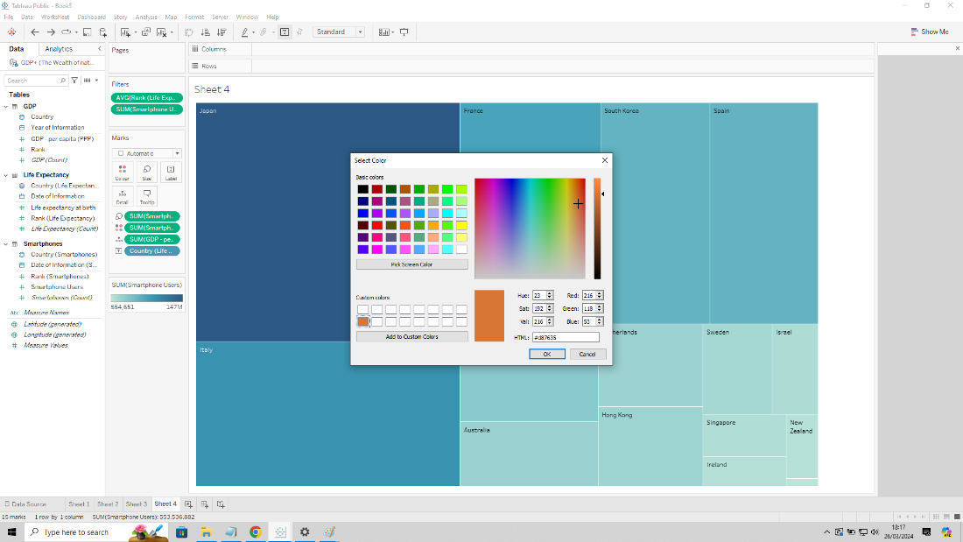

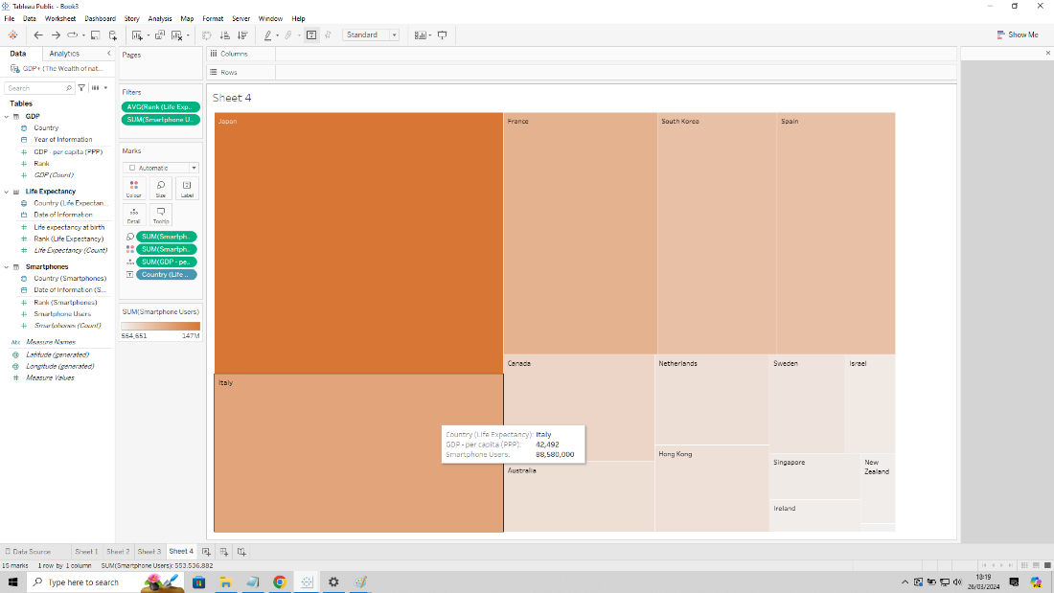

Title was edited by clicking on the title box.

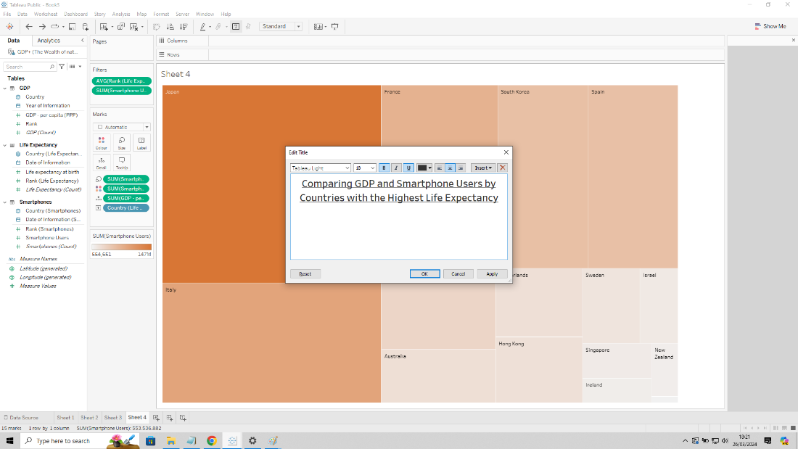

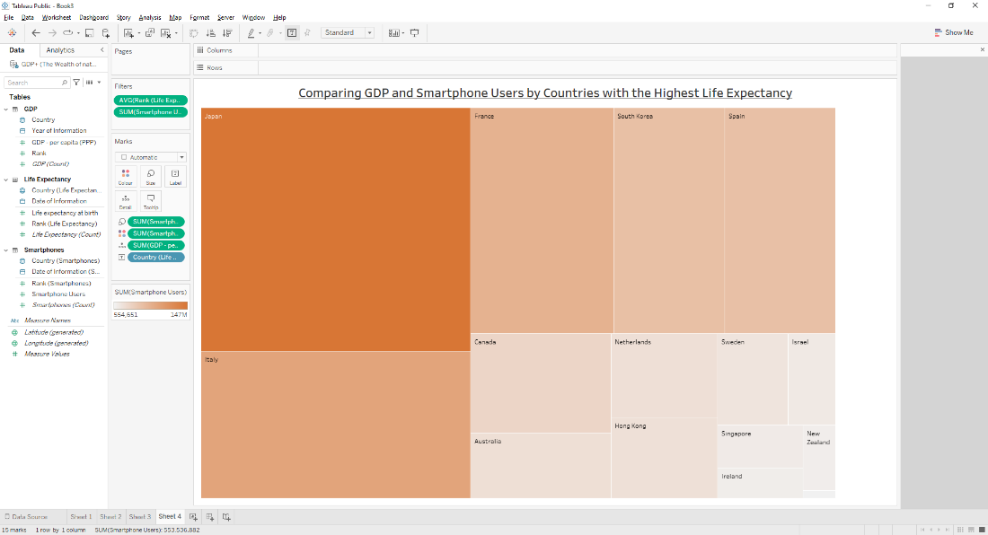

Finally, to make it clearer visually I also edited the country label text by right clicking ‘Country (Life Expectancy)’ label and selecting Format.

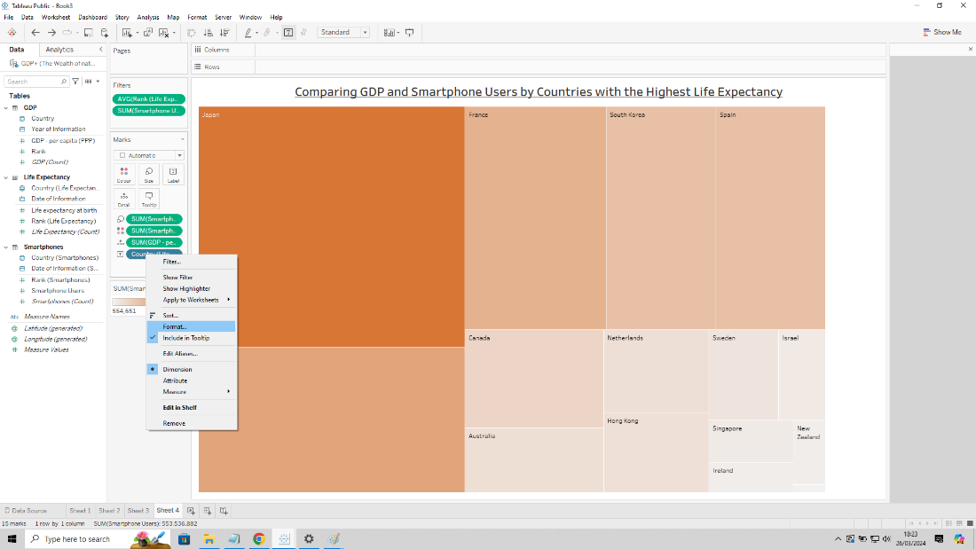

Once selected on the side bar under ‘Pane’ tab I clicked the drop down for ‘Font’ and adjusted the size and bold.

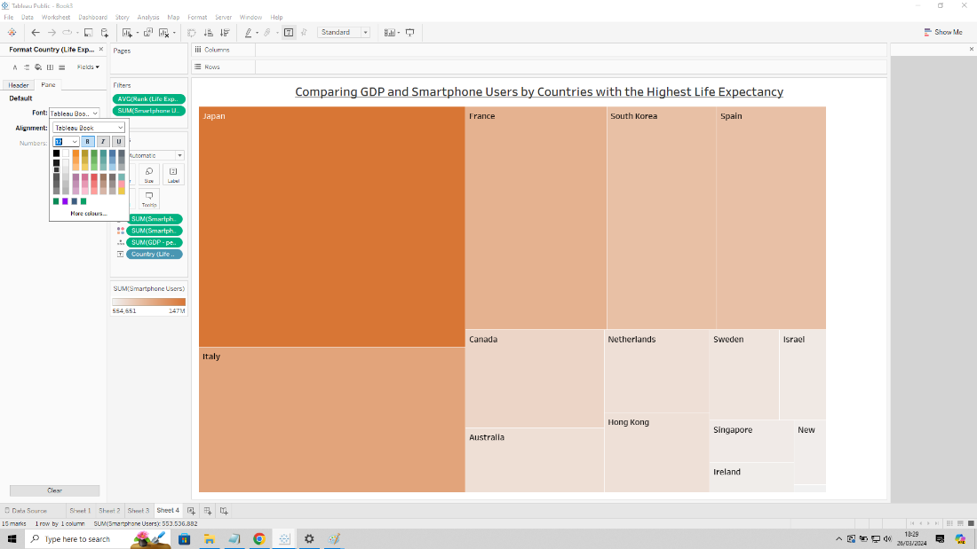

**Fifth Chart:**

I wanted to create a chart that compares GDP per capita (PPP) and life expectancy to Top 20 ranking countries based on smartphone users. I wanted to show this as a butterfly bar graph.

I started by creating a new sheet called Sheet 5.

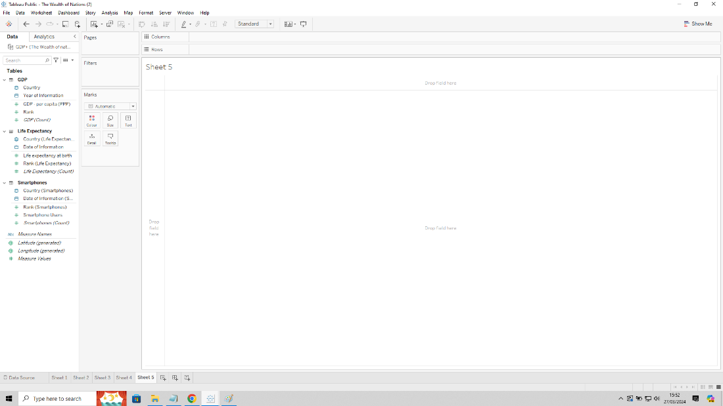

I then dragged and dropped string ‘Country (Smartphones)’ to Row and numerical ‘GDP per Capita (PPP)’ and numerical ‘Life expectancy at birth’ to Column.

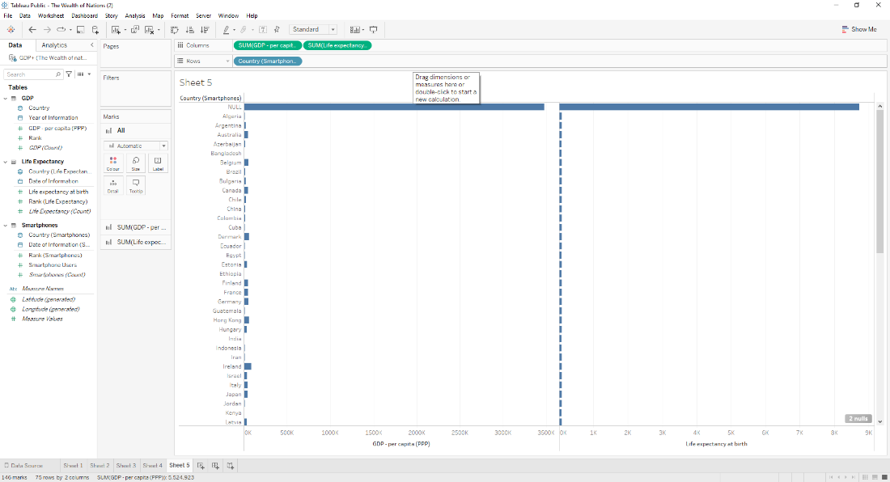

To show the top 20 countries by smartphone users I then filtered the data by dragging and dropping numerical ‘Rank (Smartphones)’ into Filter, selected Average and set the range values as 1 to 20.

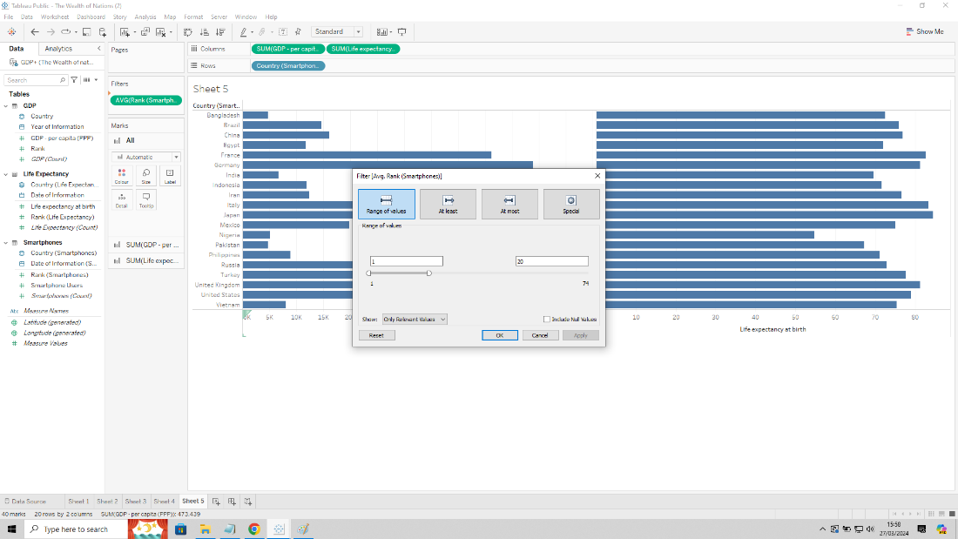

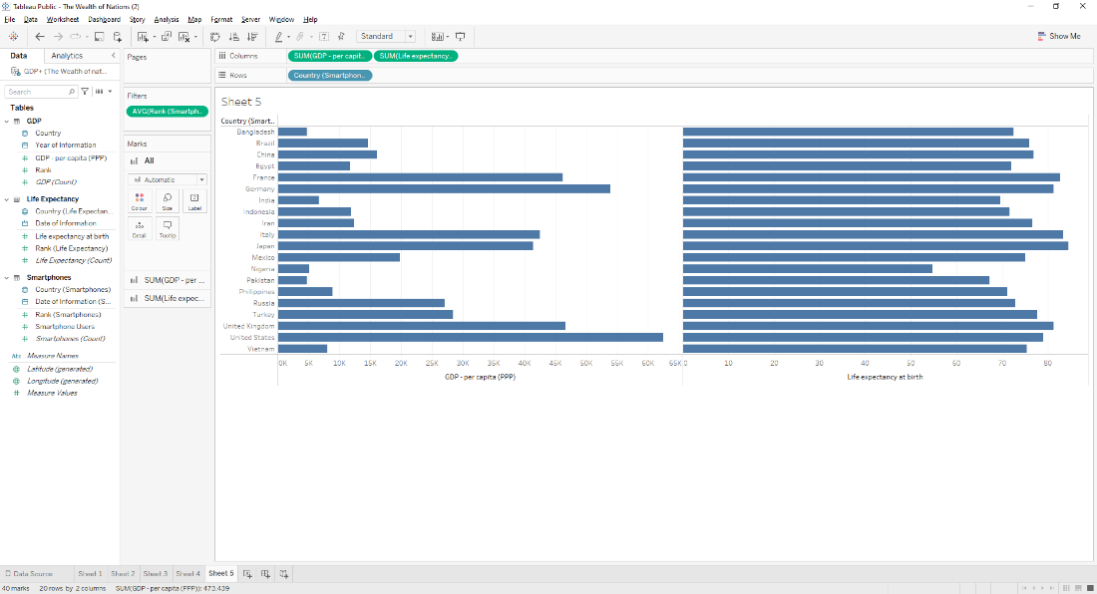

I wanted the bars to show the respective data numbers, so I expanded on the GDP graph by clicking on the ‘SUM(GDP per capita (PPP))’ tab and dragging and dropping the numeric ‘GDP per capita (PPP)’ into Label.

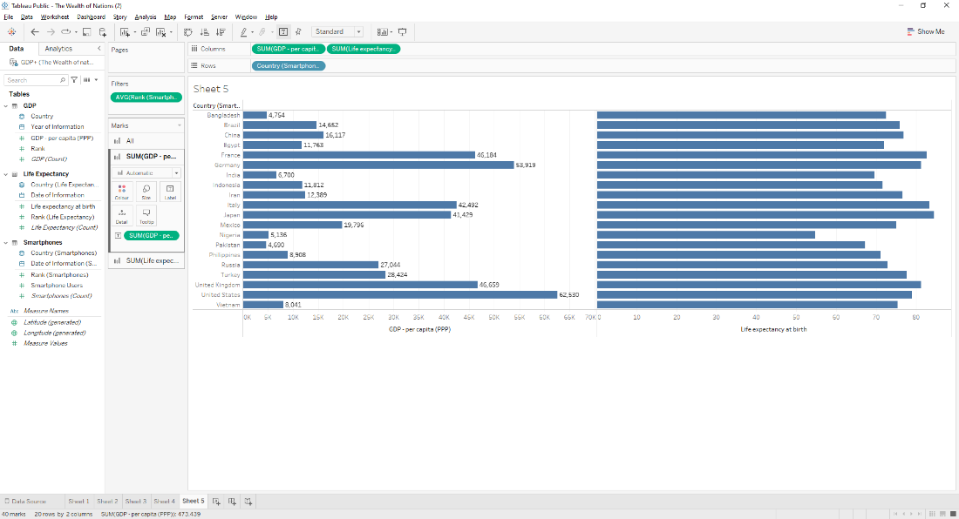

I repeated the last step for life expectancy by expanding the ‘SUM(Life Expectancy)’ tab and dragging and dropping numeric ‘Life expectancy’ into Label

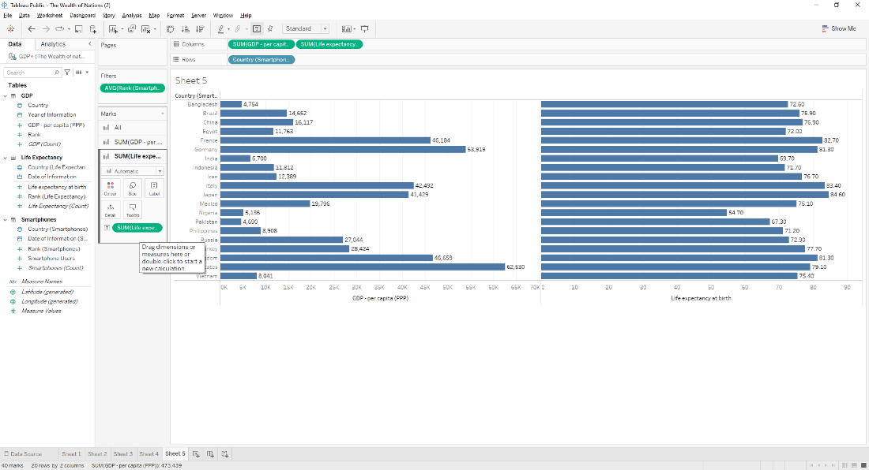

Now I wanted to sort by having the highest country with smartphone users, so I dragged and dropped numerical ‘Smartphone Users’ to Column.

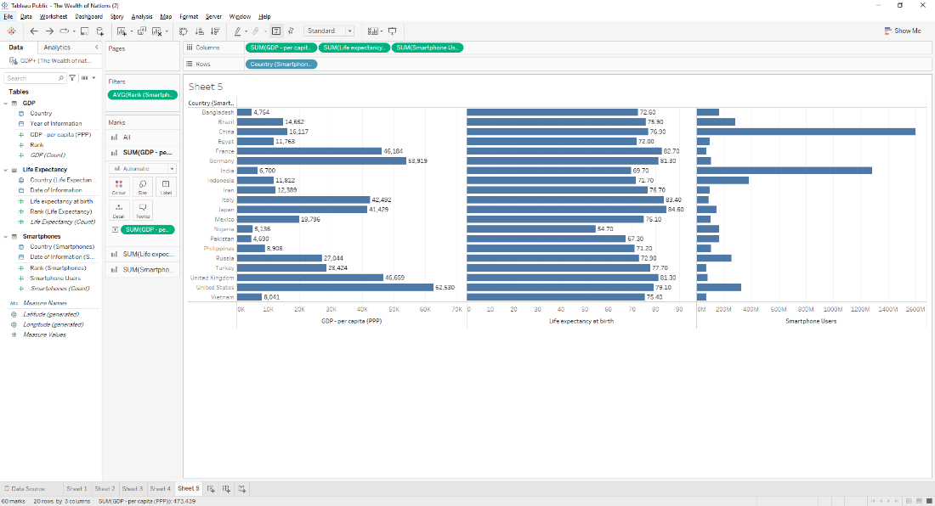

I sorted the chart out using the icon next to ‘Country (Smartphone Users)’ column and clicking ‘Field’ then ‘SUM(Smartphone Users)’.

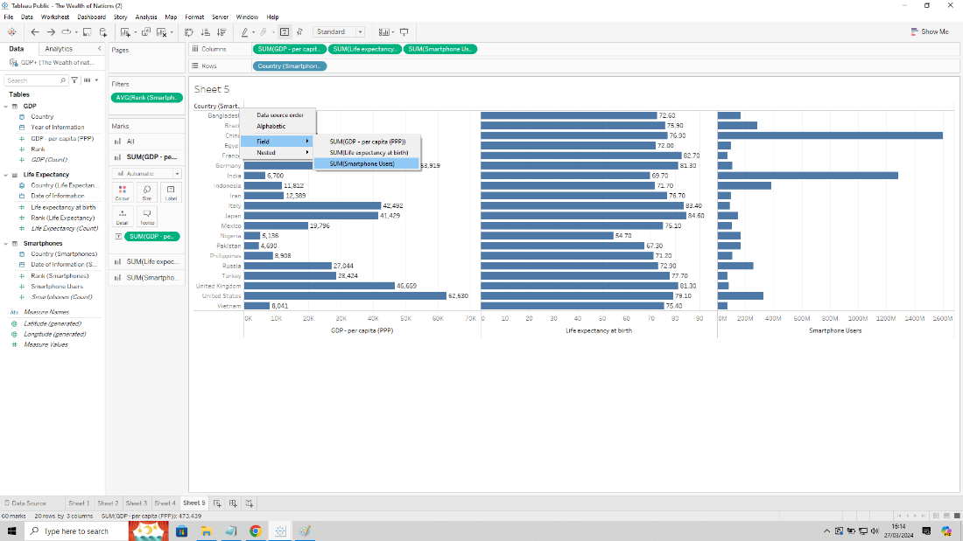

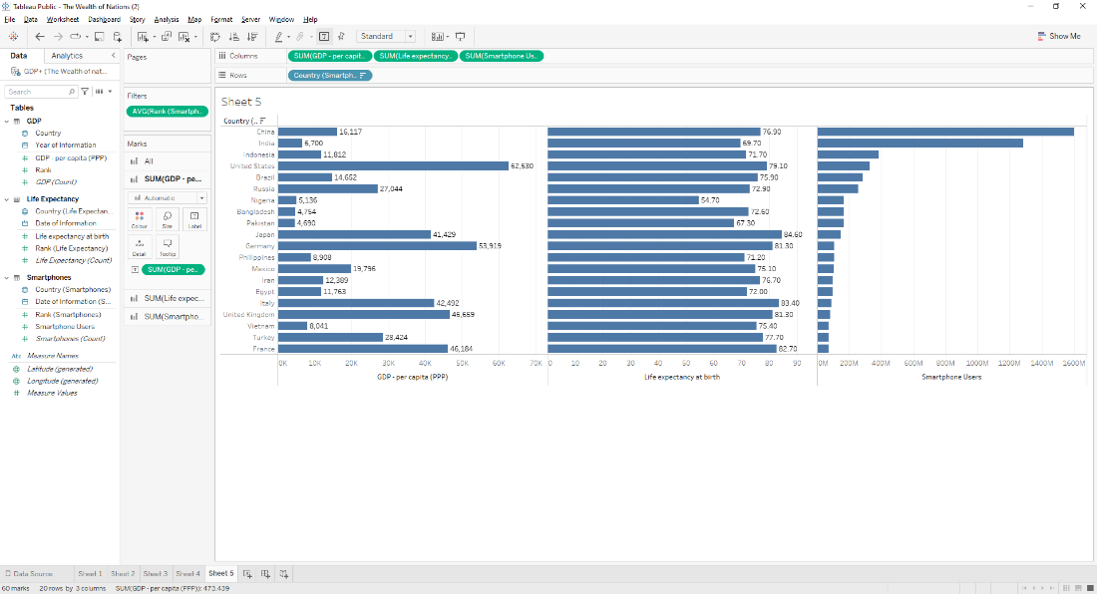

I then removed the ‘SUM(Smartphone Users)’ from Column so the bar charts only showed GDP and life expectancy.

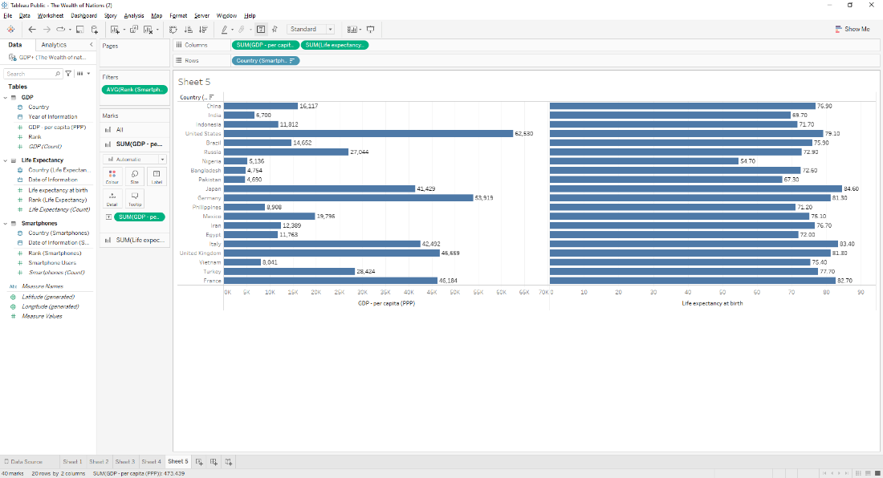

To make it into a butterfly bar visual I initially right clicked the axis range on the GDP graph and selected Edit Axis.

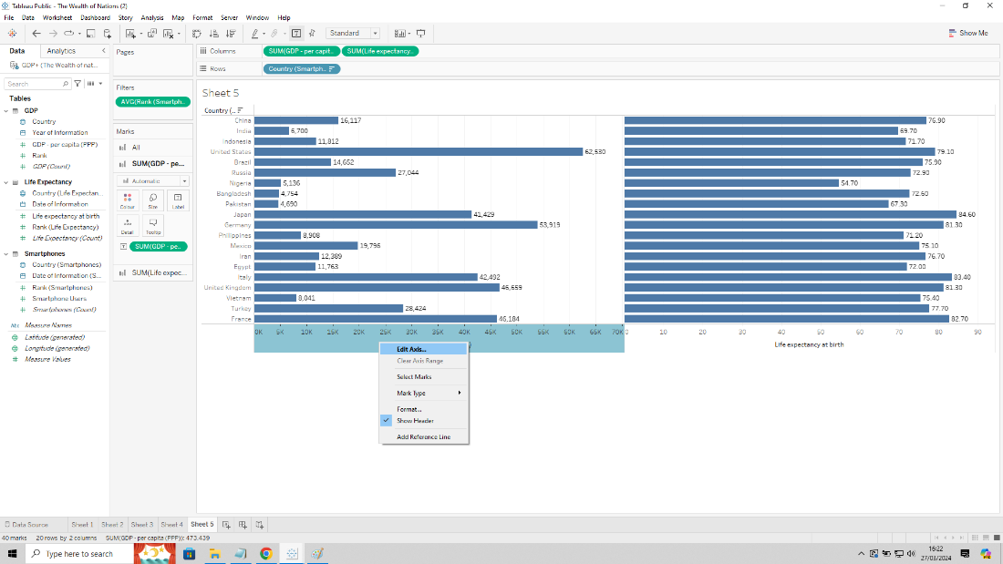

In the menu I then selected ‘Reverse’ to swap the bars to the right.

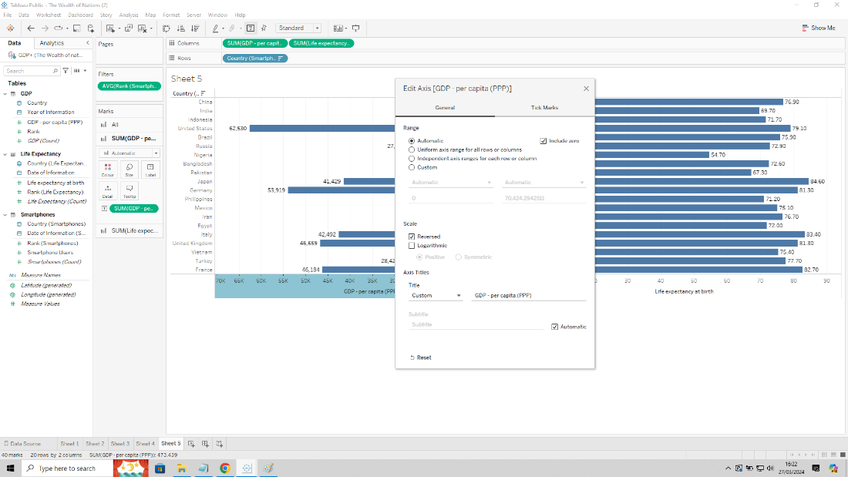

I wanted the country names to appear in the middle, so I created a calculated field by right clicking in the ‘Data’ tab and selecting ‘Calculated field’.

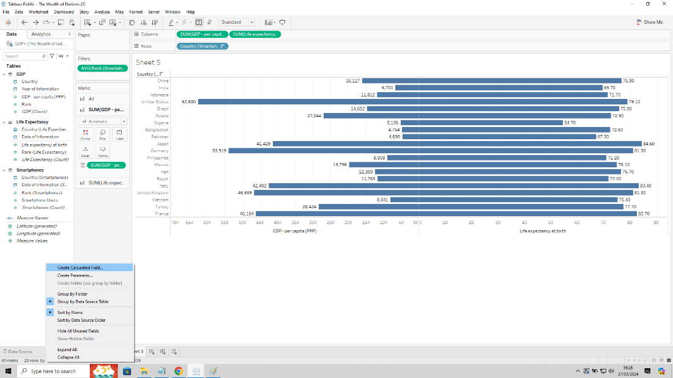

In the box I adjusted the title to be called “0 axis” and added the zero value in the value box, then pressed OK.

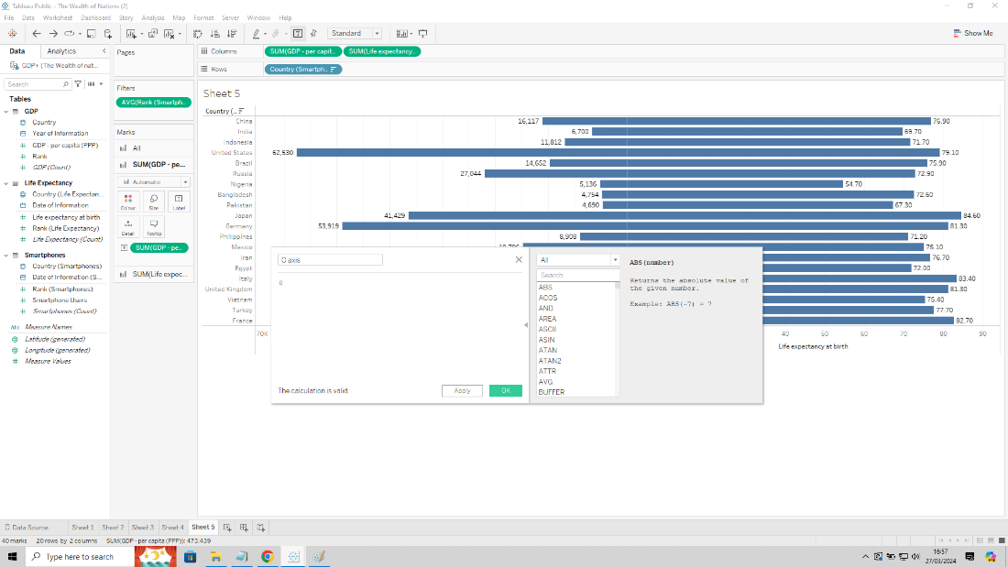

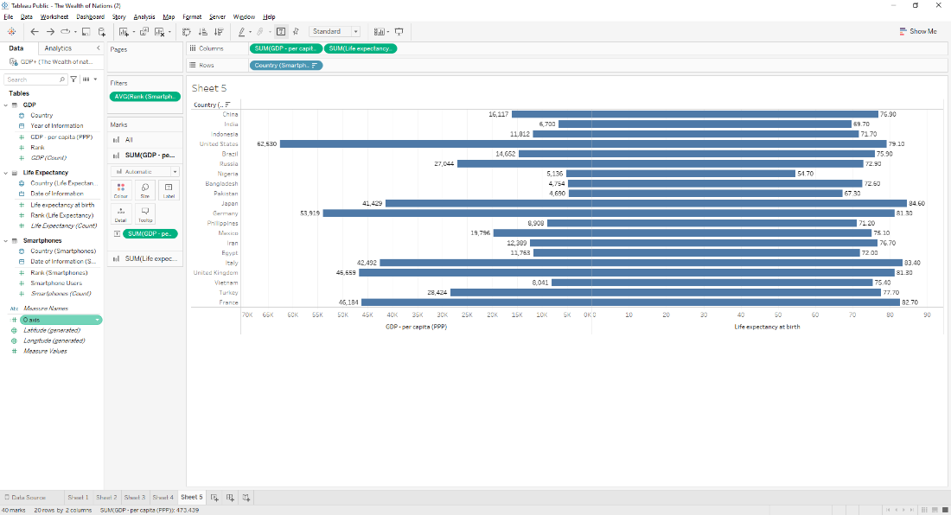

To create a divide between the two graphs I placed the created calculated field between the two numerical data in Column.

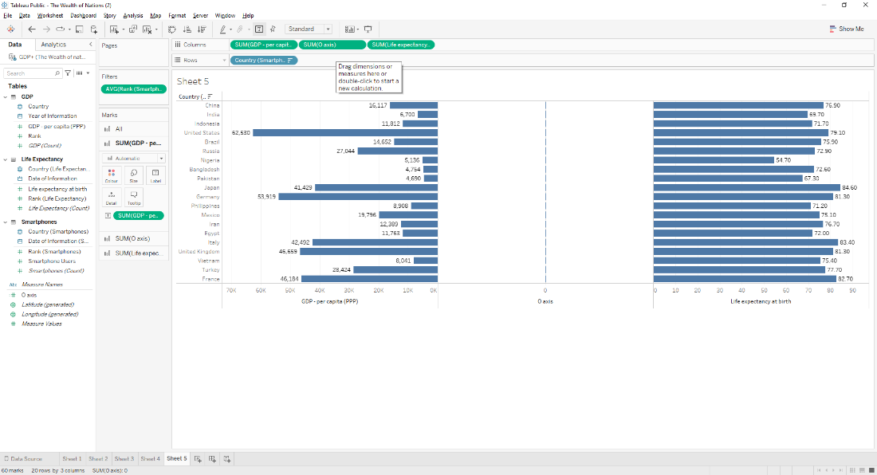

In order, for me to have the country names show in the middle I dragged string ‘Country (Smartphones)’ to the Label in the ‘SUM(0 axis)’

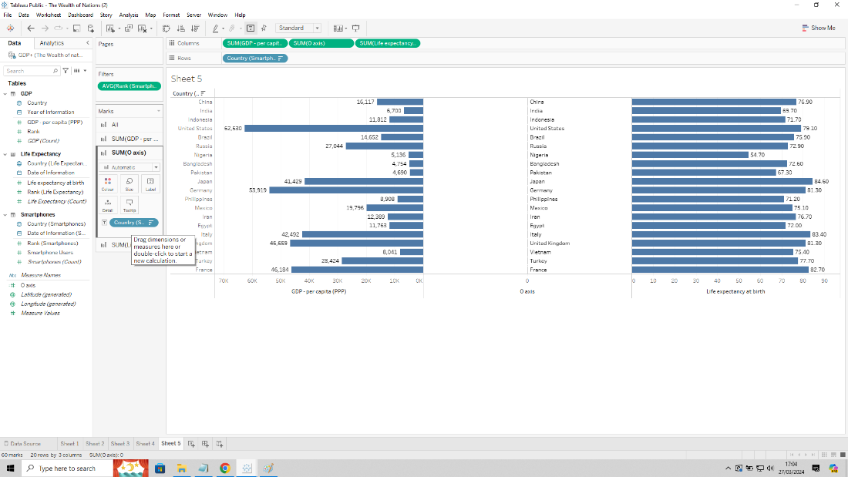

To make it visually appealing I clicked on Label then Alignment and changed the horizontal alignment to centre.

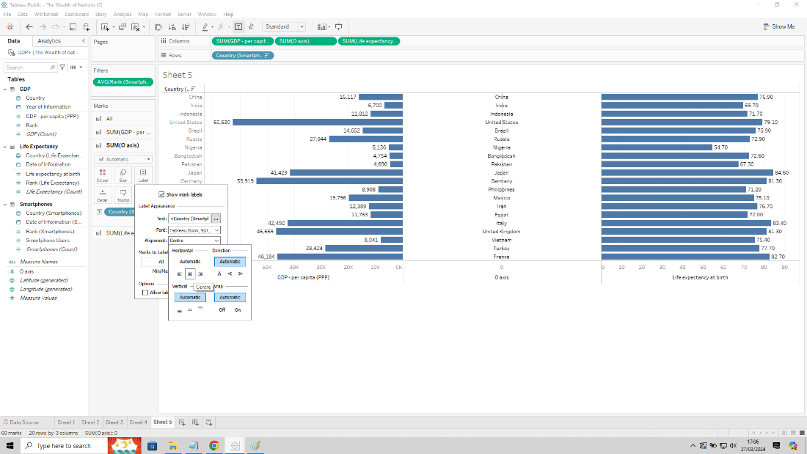

I also changed the title of the axis by right clicking the axis title area and selecting Edit Axis.

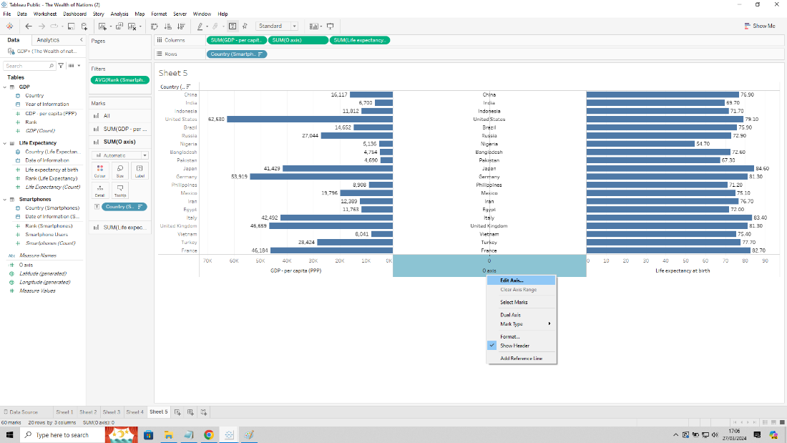

Went to Custom text box and changed it to “Country”.

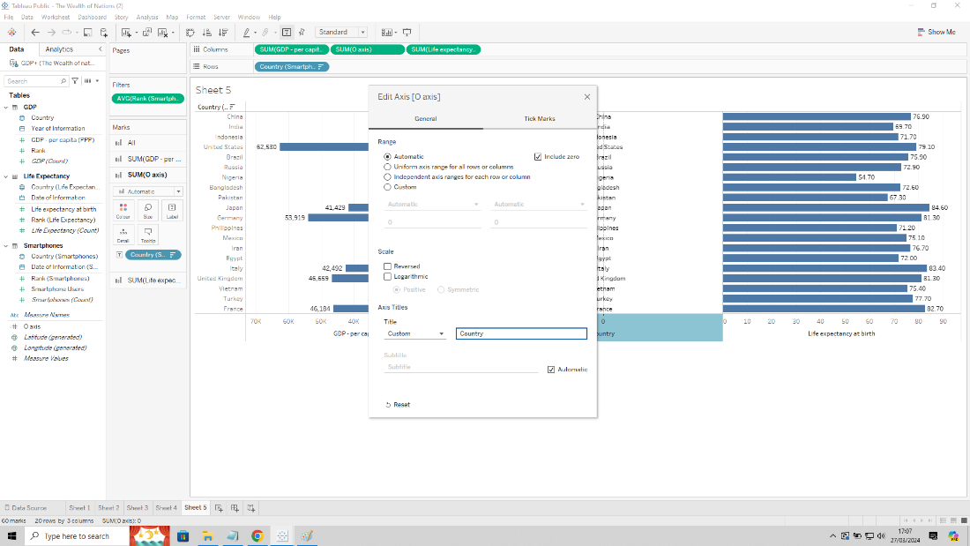

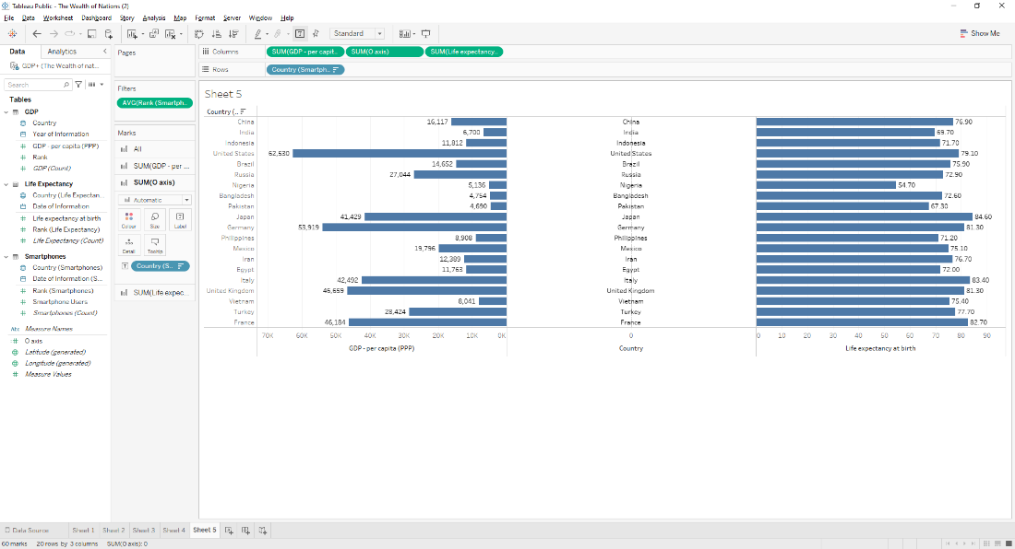

Changing the colour of the life expectancy graph required me to click on the ‘SUM(Life expectancy at birth)’ and under Colour I picked orange to make it colourblind friendly.

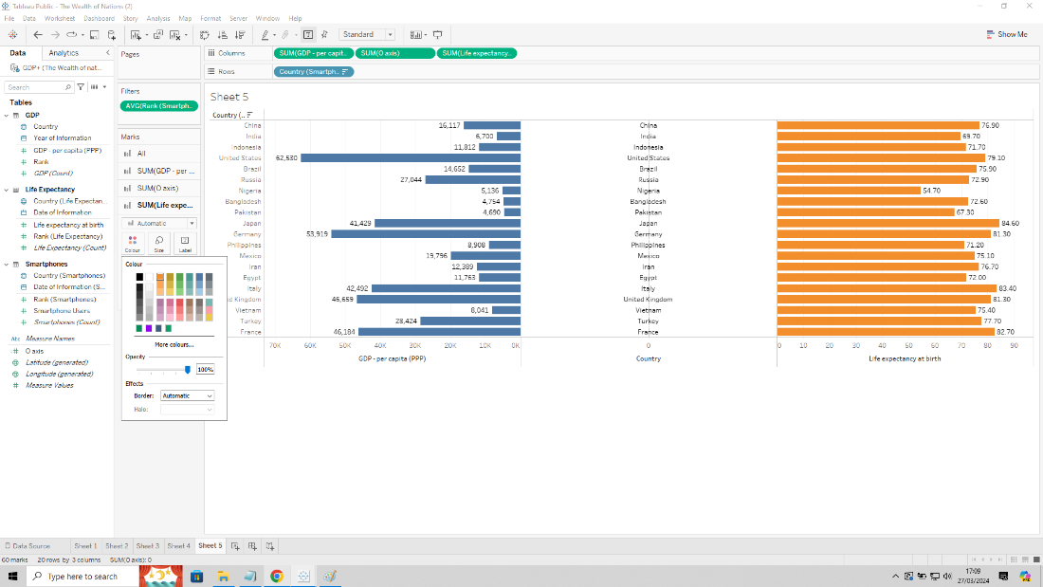

To remove the countries listed on the left side I right clicked on string ‘Country (Smartphone Users)’ on the Row and deselected ‘Show Header’

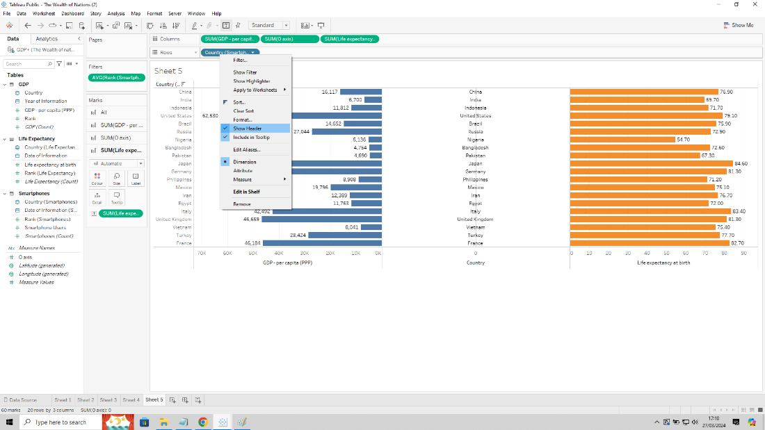

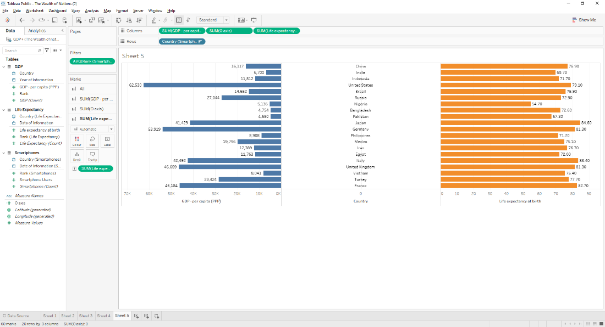

To make the middle axis neater I decided to go to the ‘SUM(0 axis)’ tab and select ‘Text’ in the drop-down menu.

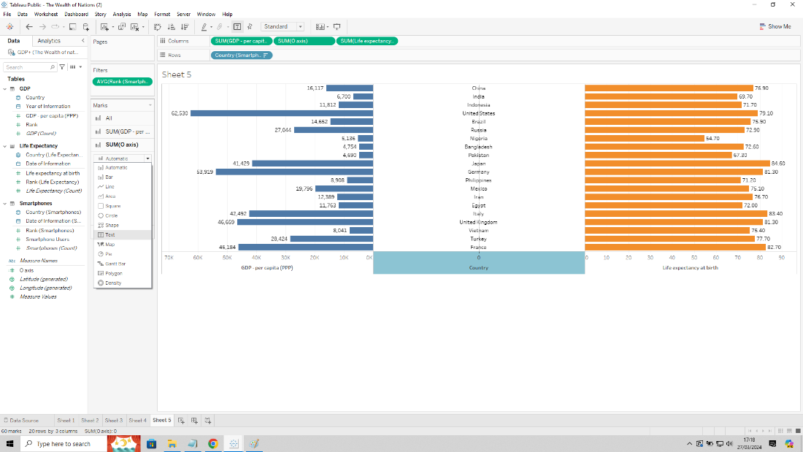

I wanted to get rid of the line in the middle, so I right clicked on the text and selected Format

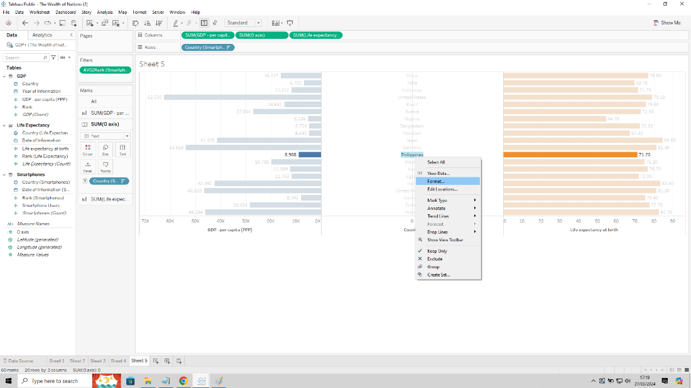

In the Format menu under Lines, I then went to Column tab and selected None for Grid lines and Zero lines.

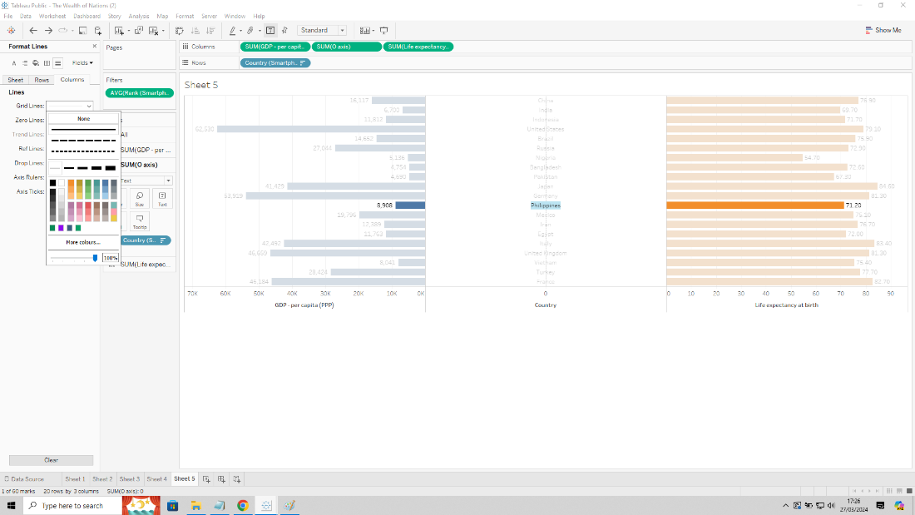

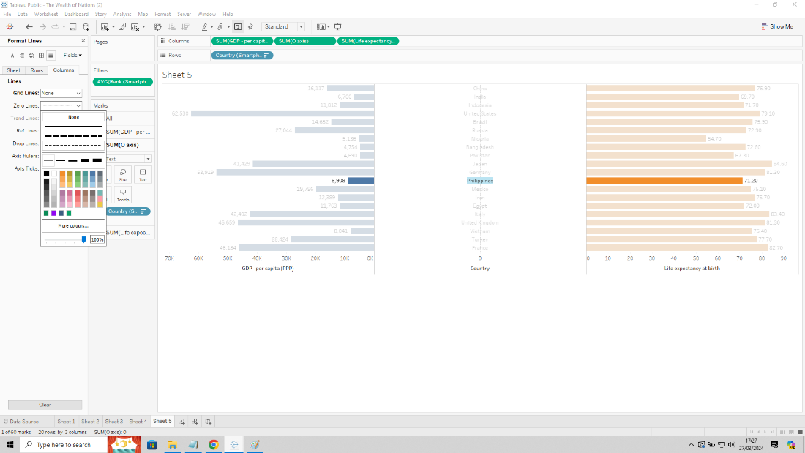

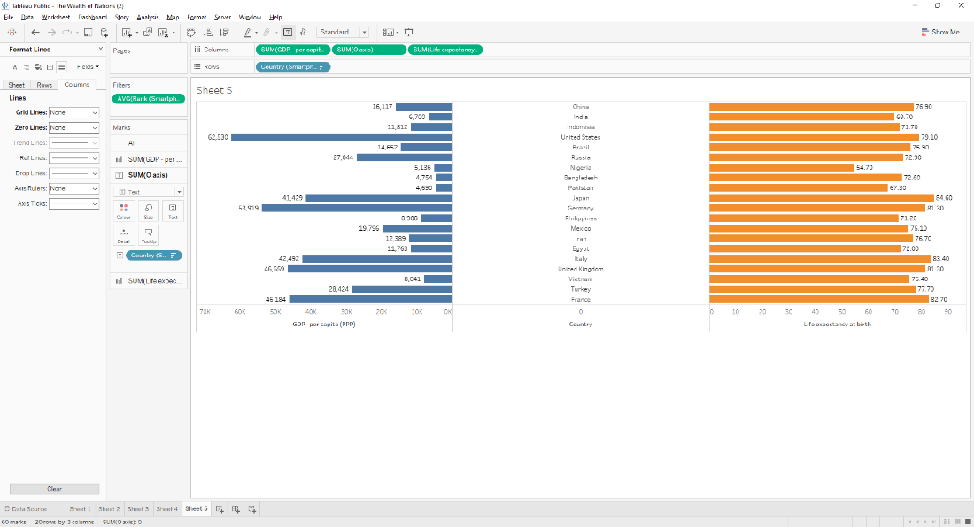

I also wanted to remove the zero in the “Country” axis, so I right clicked the area and selected Edit Axis. I clicked on the Tick tab and selected None for Major Tick Marks.

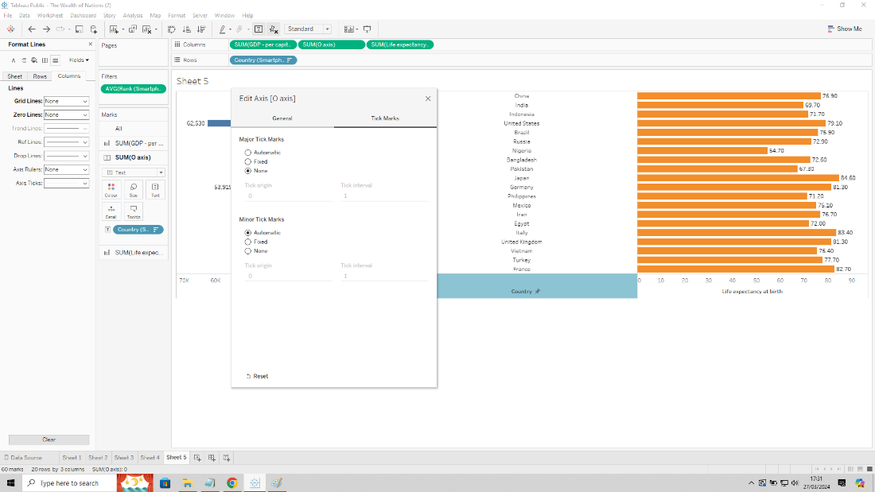

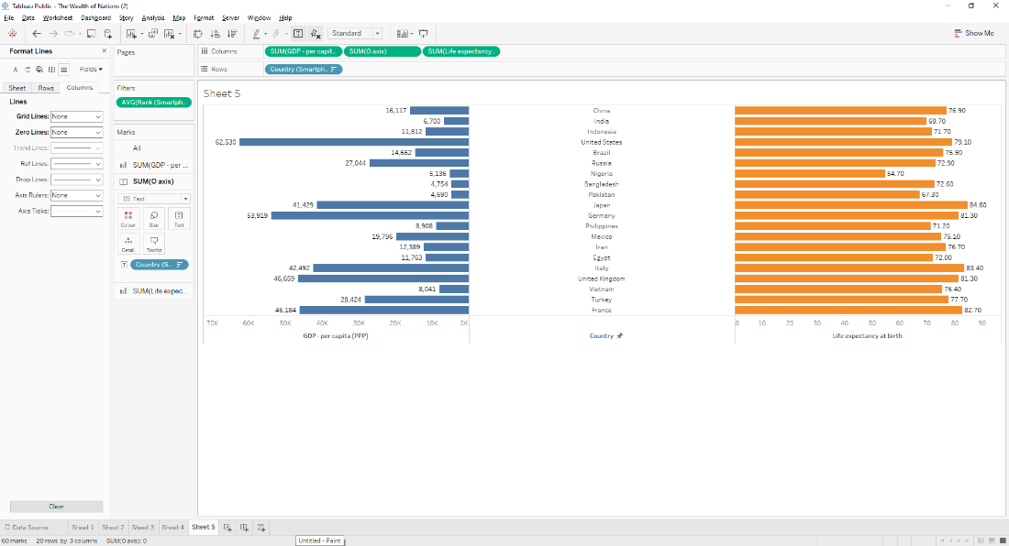

The title was edited by clicking on the title area and adjusted the size, bold and alignment.

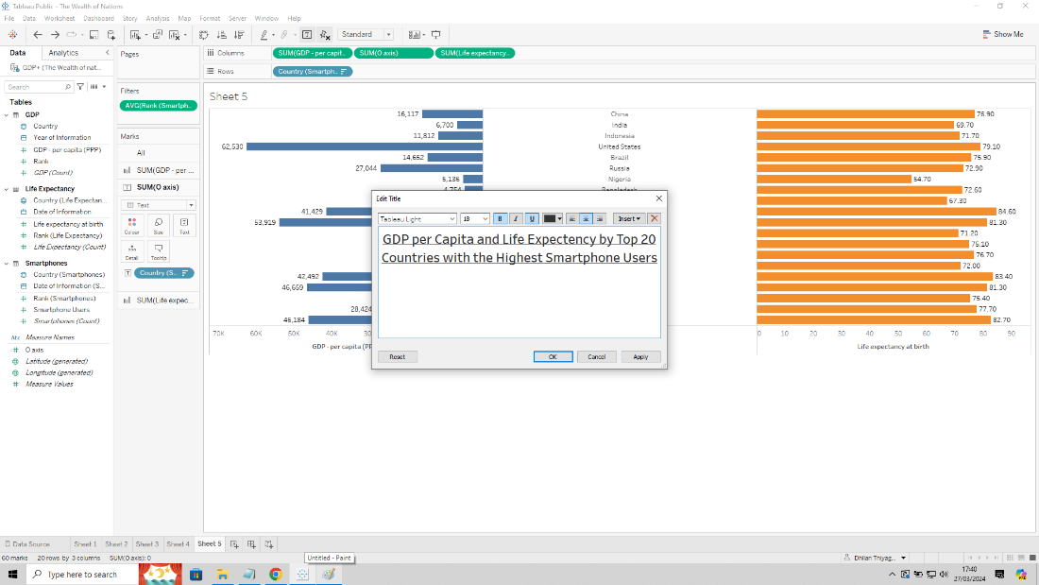

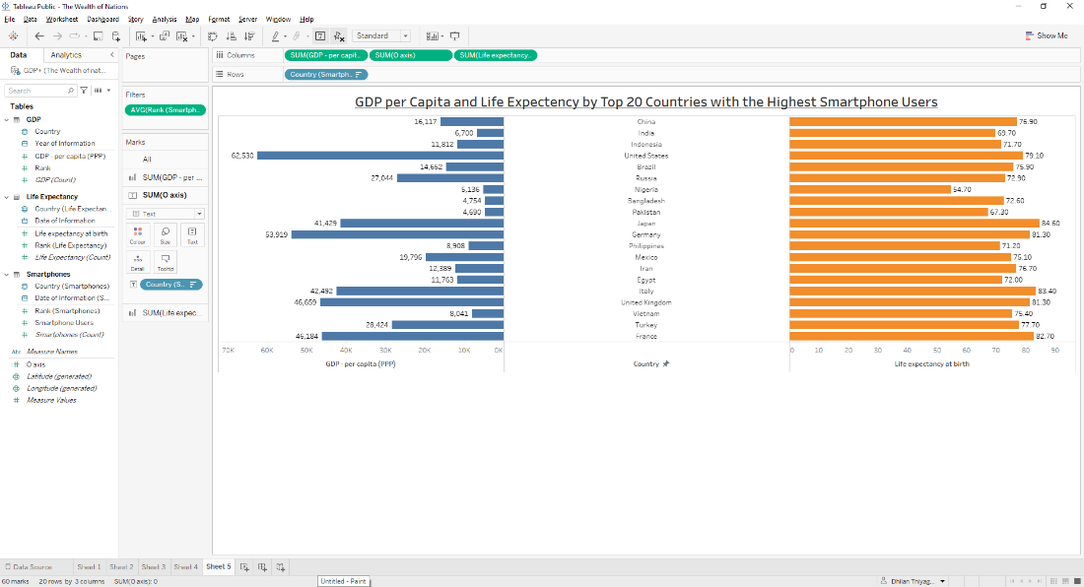

I also wanted to include the smartphone user data on the chart, so I dragged numerical ‘Smartphone Users’ to the Detail box in All tab.

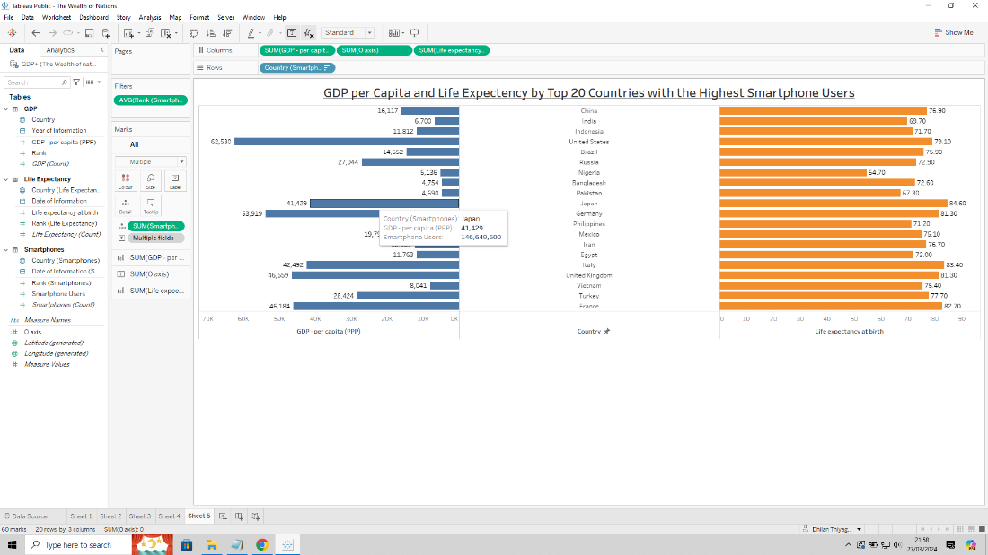

6)

**Dashboard creation:**

Initially I renamed each sheet to reflect the title of the chart.

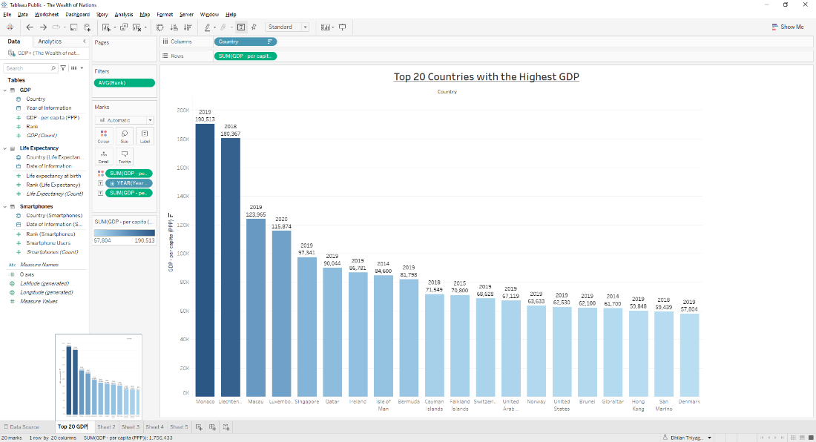

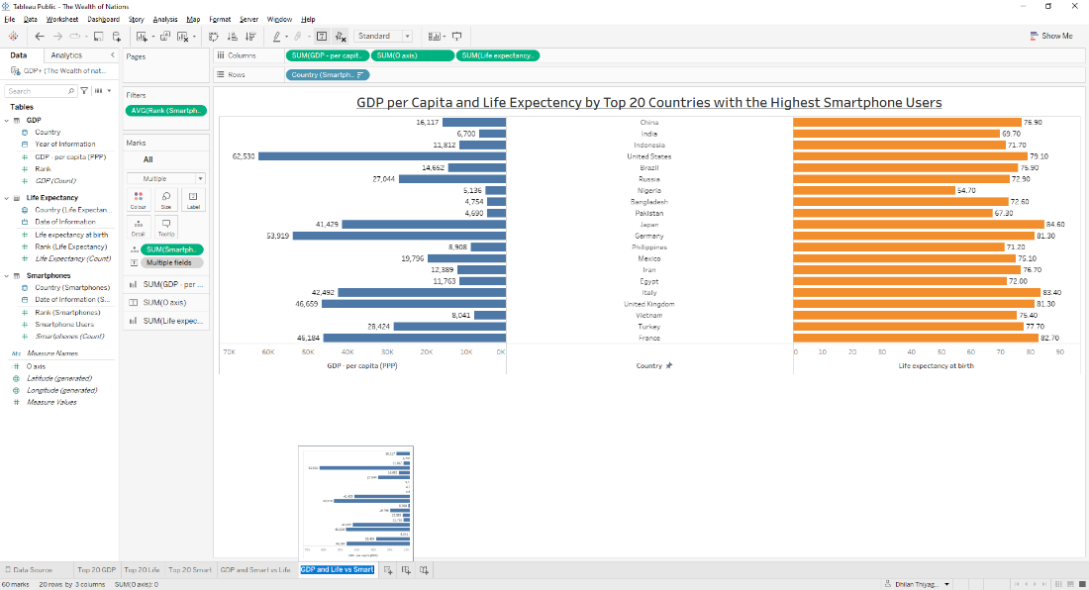

To generate a dashboard, I selected the New Dashboard icon next to New Worksheet icon. This created a canvas to edit the dashboard.

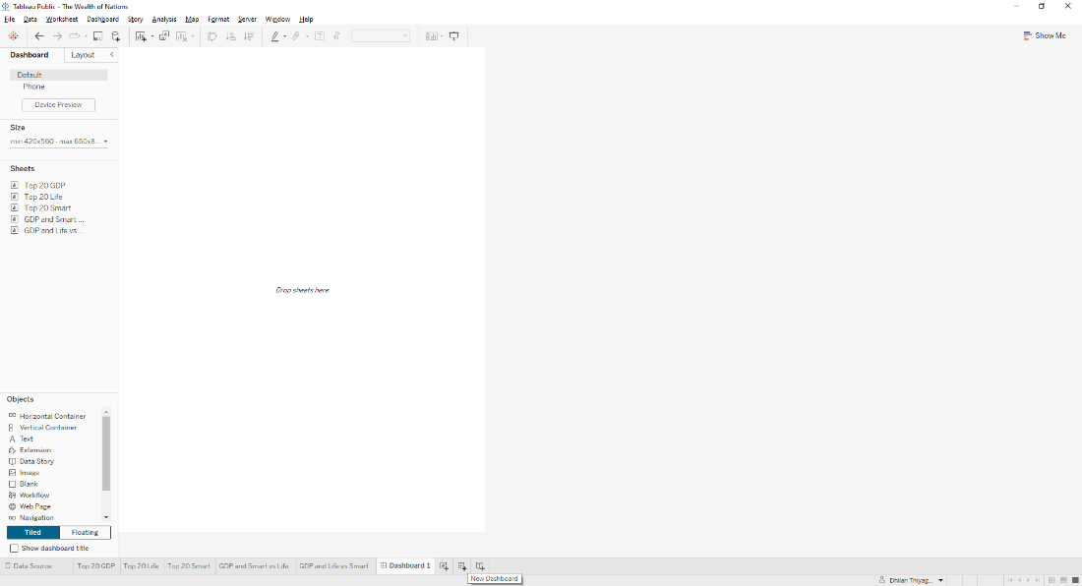

Then renamed it as “The Wealth of Nations”.

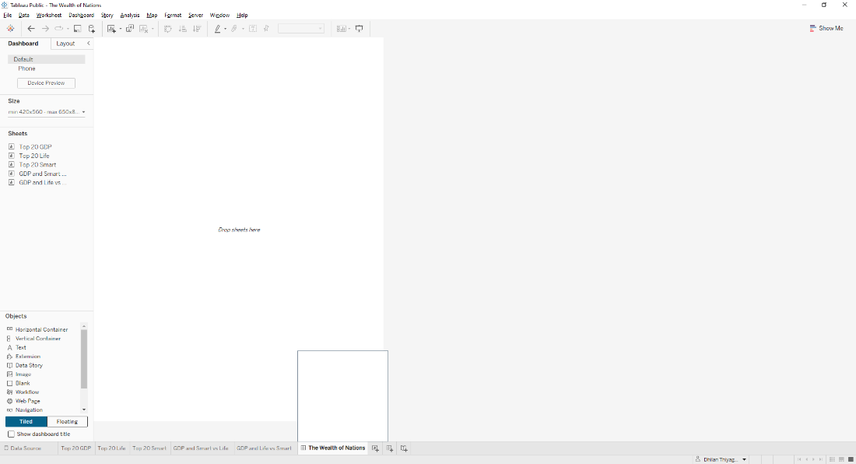

I readjusted the size to Automatic so the canvas can dynamically adjust to the size of my sheets.

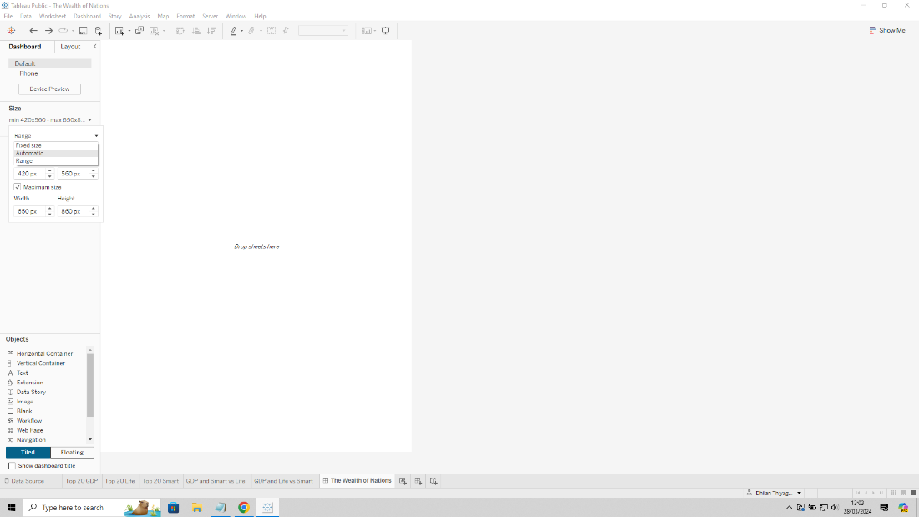

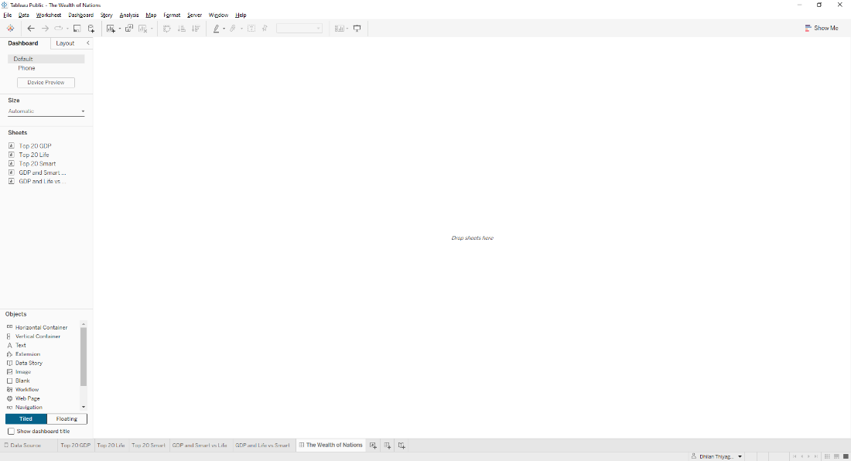

I then dragged and dropped the sheets on the Sheets tab to the left and moved them around to make it visually appealing.

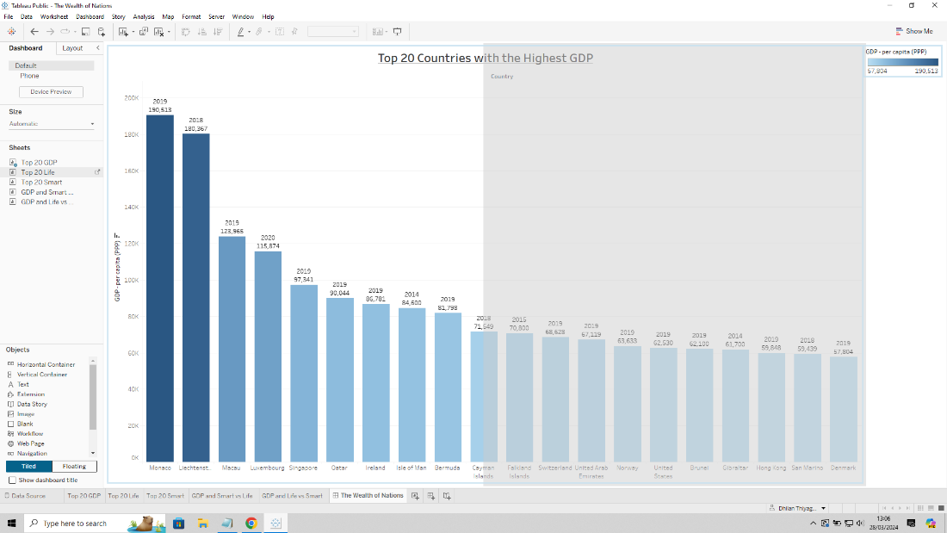

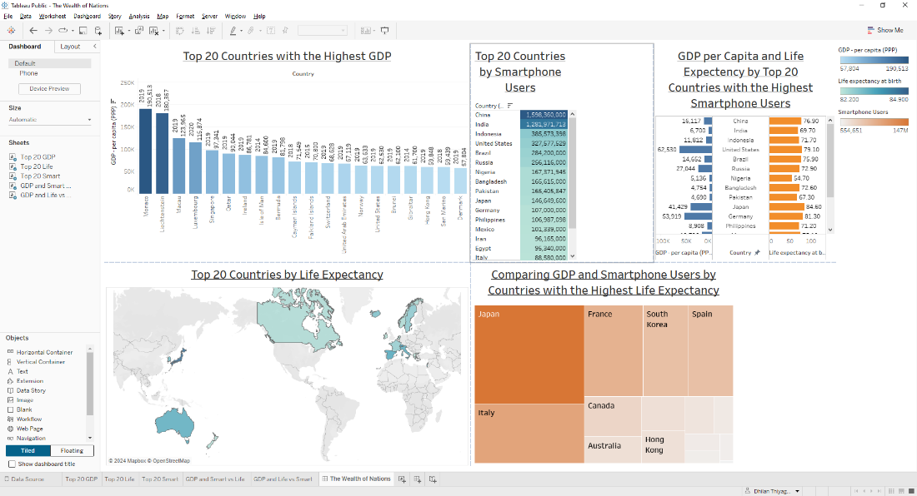

To make it more visually presentable I right clicked each chart and selected Fit then Entire View. I also readjusted each chart so it would fit better in the dashboard by hovering over the border and stretching or collapsing the lines.

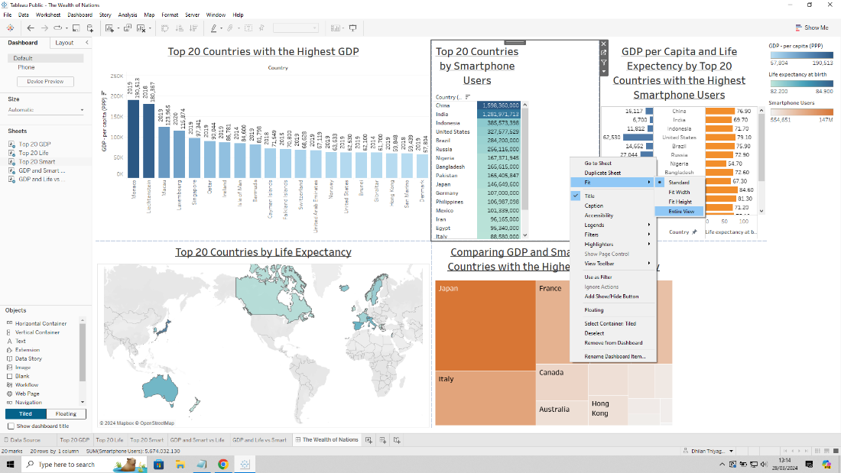

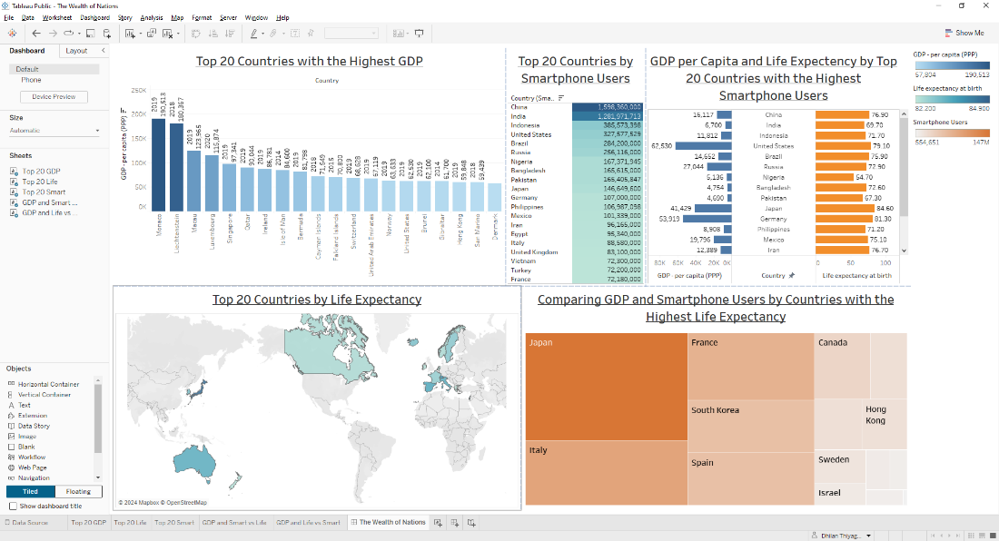

I wanted the legends on the side to be incorporated into the chart. To start I clicked on the drop-down arrow for the ‘GDP per Capita (PPP)’ legend and selected Floating so I can move the legend to the Top 20 GDP chart without it affecting the chart adjustments. I did the same for ‘Life expectancy at birth’ legend.

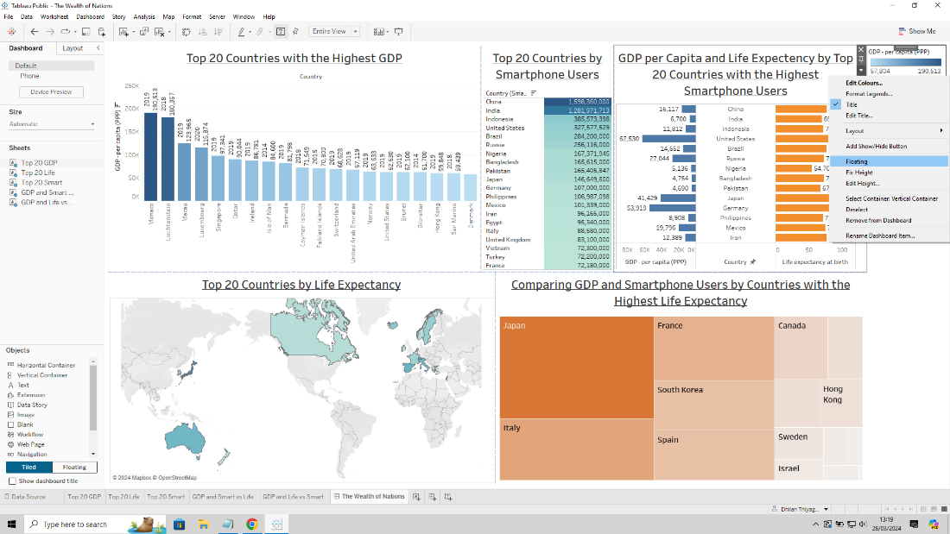

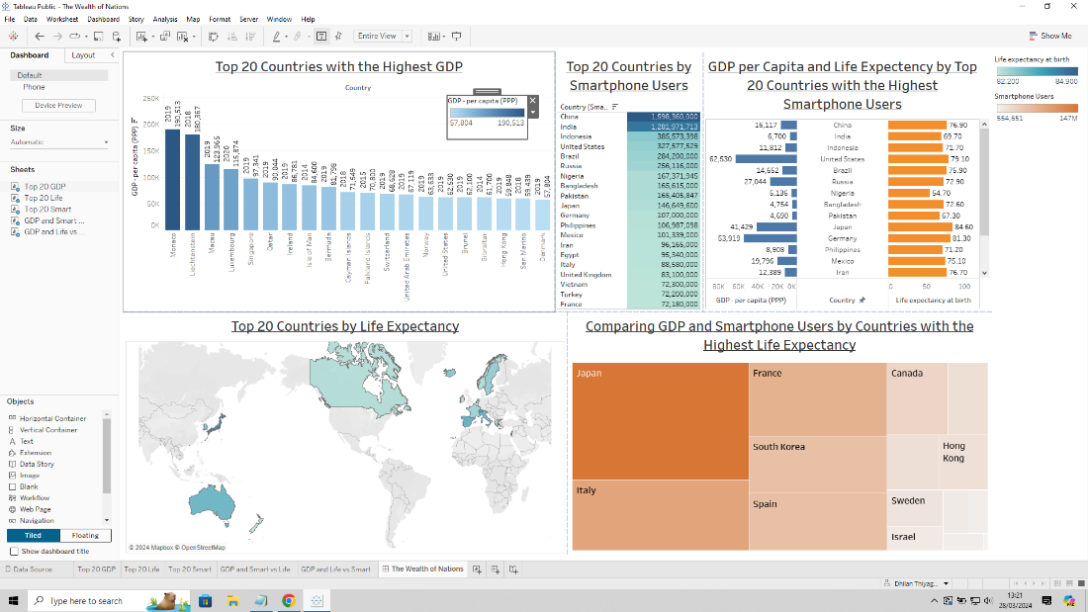

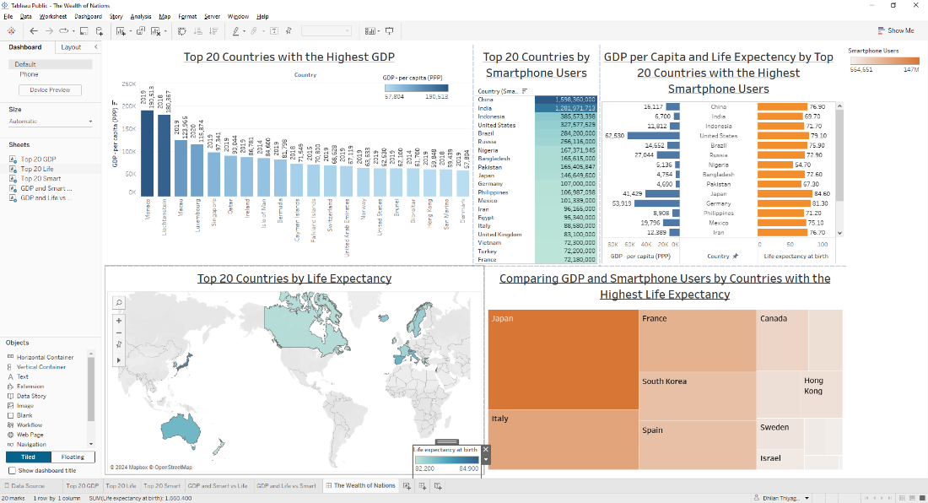

For ‘Smartphone Users’ legend I wanted it under tree map, so I chose not to do it as a float and simply dragged them to the area below the chart.

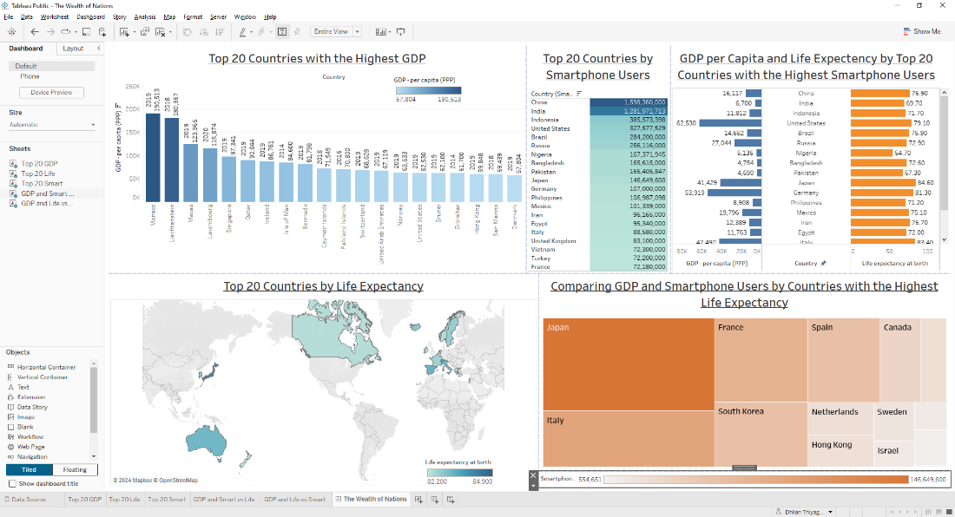

I wanted to add a title to the dashboard, I went to Dashboard menu at the top and selected Show Title.

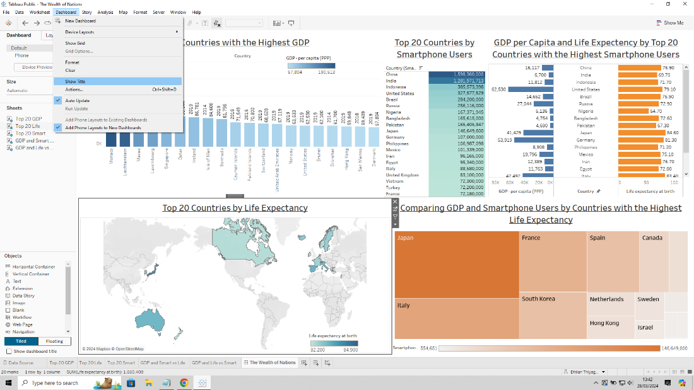

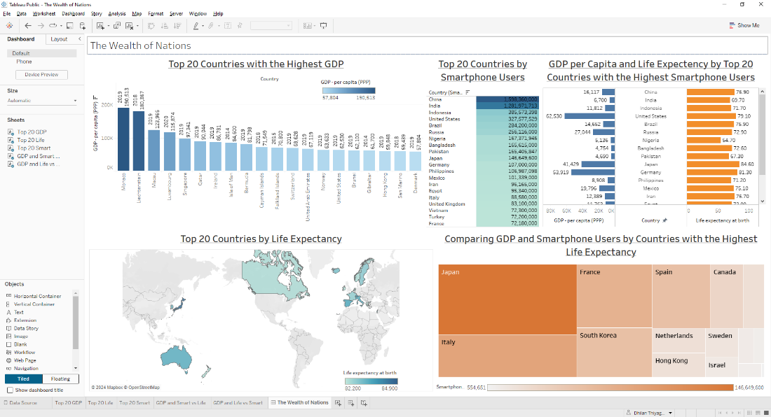

I adjusted the format by selecting the title box.

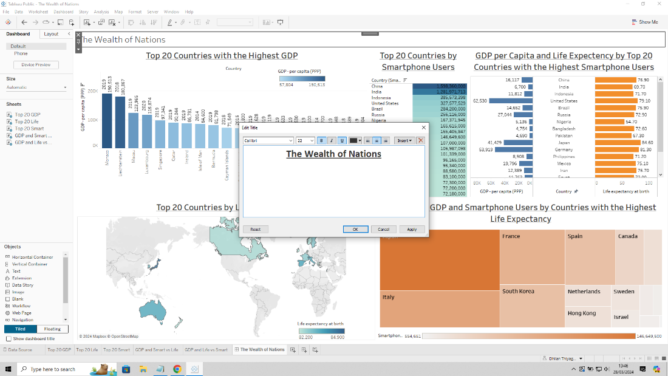

At this point I noticed there was a spelling mistake on my fifth chart, I went back to the ‘GDP and Life vs Smart’ tab and amended “Expectency” to “Expectancy”. This change reflected on the dashboard.

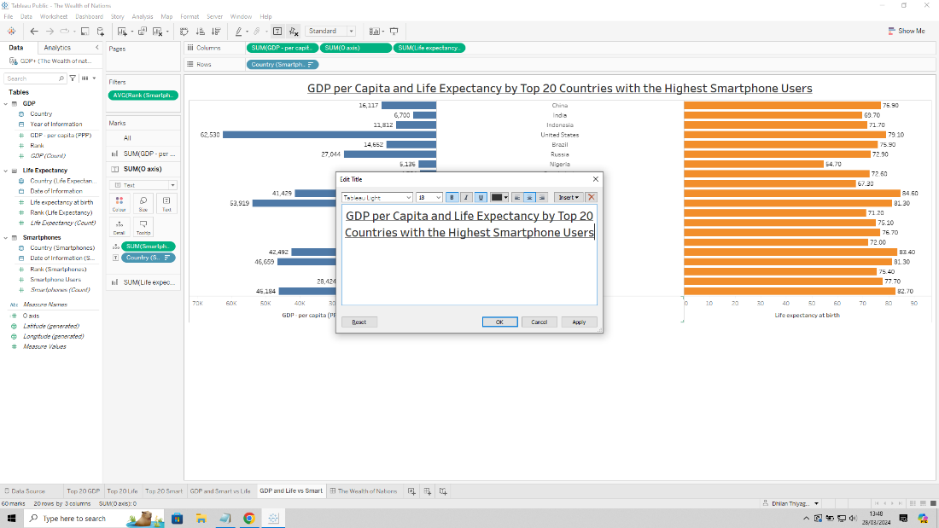

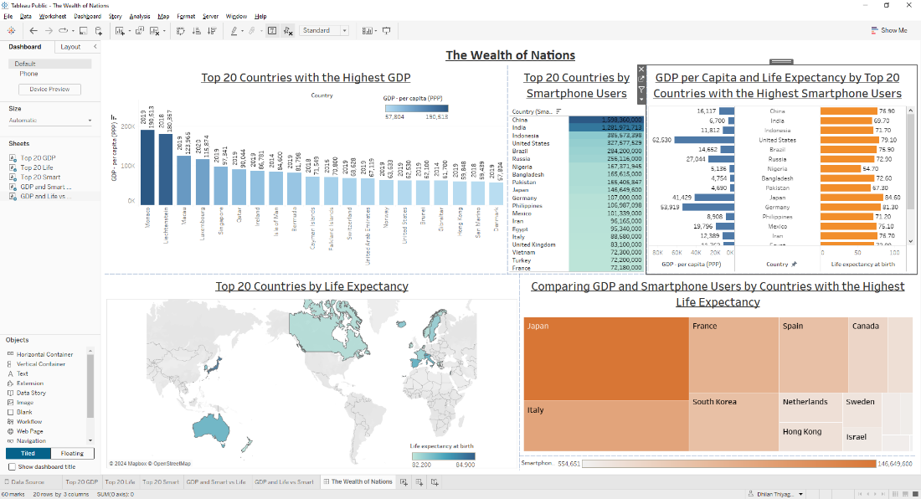

I wanted the information displayed to be dynamically filtered based on life expectancy, so I decided to use the world map chart as a filter. To do this I selected the filter icon Use as Filter on the chart’s side menu.

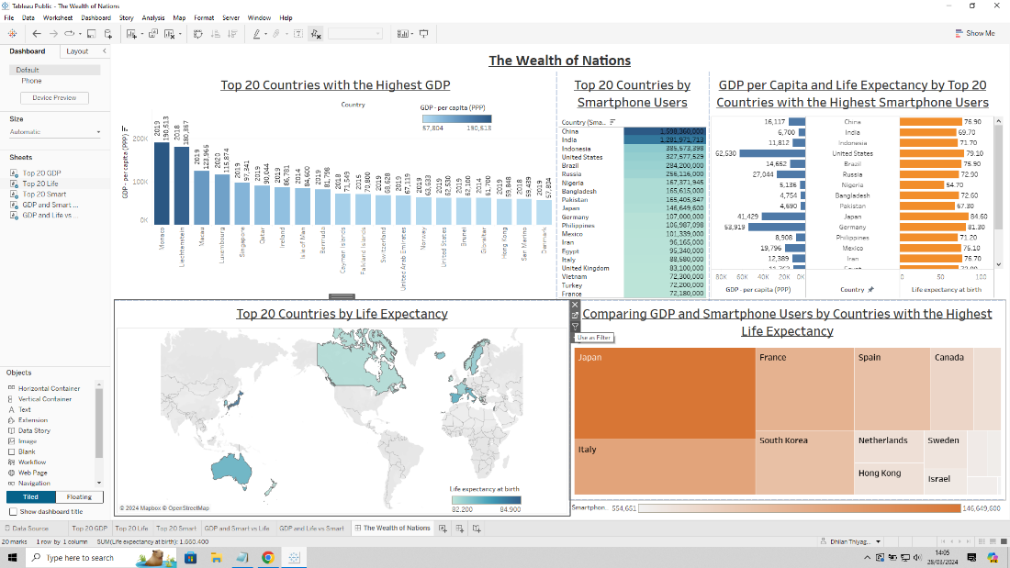

When selected I can select one of the top 20 countries for life expectancy and see data from other charts corresponding to it.

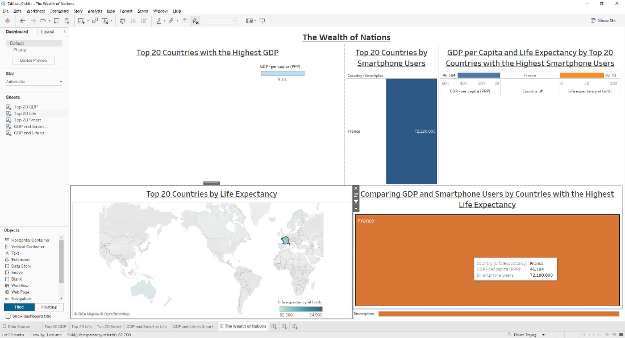

As I was happy with my dashboard I went to File, then Save to Tableau Public as, a login pop up will appear if I haven’t logged in so I log in to my account and titled the Dashboard as The Wealth of Nations.

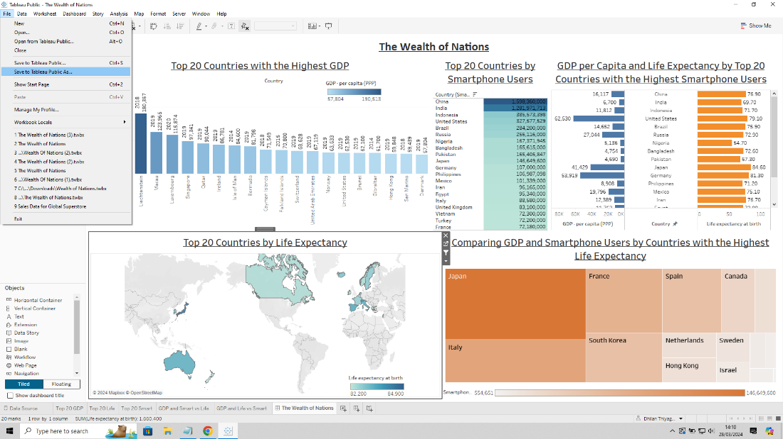

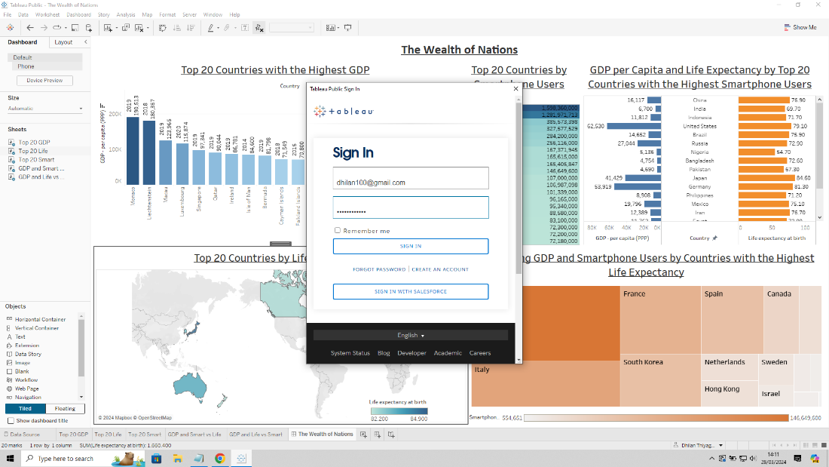

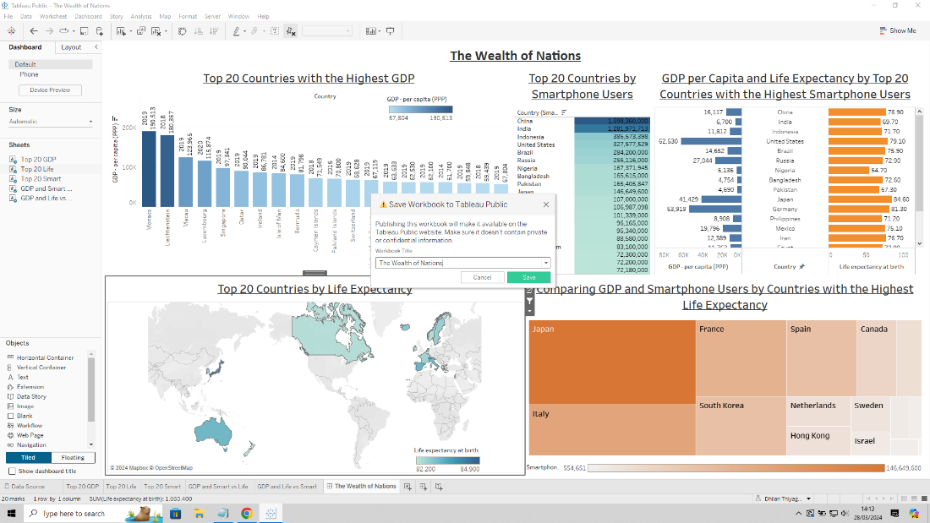

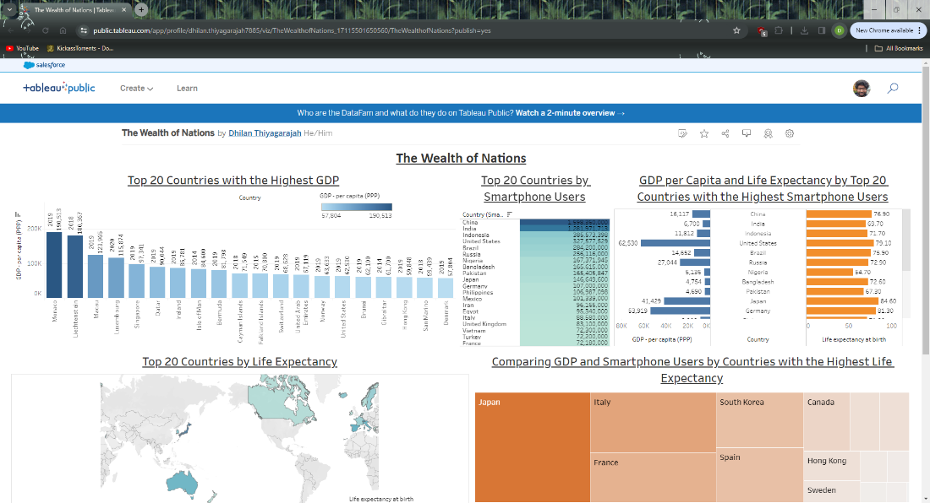

**Link:**

<https://public.tableau.com/app/profile/dhilan.thiyagarajah7885/viz/TheWealthofNations_17115501650560/TheWealthofNations>

**Reflective Learning:**

I found the overall experience of utilising Excel and Tableau as a way of visualising data enjoyable.

Using Excel was very straight forward when dealing with data. But I found making a chart a bit complicated, as I originally wanted the graph to exclude Rank from the y axis and be plotted as information on my bars. It made the original graph with all the countries, rather hard to read from. Maybe something I could resolve with a bit of research. I was still able to change the format of the titles and simplify the axis to make it more presentable. Sorting and filter were easy to use, though I did notice Excel wouldn’t show the filter drop down arrow for all columns sometimes, so I wasn’t sure if it’s a settings issue but I did get it to work in the end. I didn’t get to use any formulas or functions, but I can see how useful they could be in finding data and answering questions.

I found Tableau fun and relatively easy to use. I was able to use a variety of chart types to display my data and I could see how the interaction aspect of the dashboard is able to help present data. I was even able to look at other people’s work and some cases reverse engineer the way they made the chart by downloading and having a look at how they constructed it. This inspired me to include those styles into my dashboard. I found the data itself wasn’t the best to fully manipulate so at the start I had to set relationships and change the year data from numerical to date type. This resulted in the dates appearing as 01/01/YEAR but was able to convert it back using the YEAR function. I also found that as the client wanted me to focus on the top 20 countries for each category, I was limited to what filter options I was allowed to present. This meant on my dashboard I couldn’t offer a general list of all the countries in the data as majority of them would show nothing. The colourblind aspect of the client also reduced my ability to use certain colour combos, but I did feel like the orange and blue I used looks great for visualising the data. Overall the dashboard came out as I intended and still had a filter option placed on the world map, so the client can click on the highlighted countries and see what other data can correspond with that country.

If I had to deal with another projecting using these two programs I would use Excel to sort, filter and manipulate data to find answers to questions the client requests, while I would use Tableau to create dashboards that the client can refer back to, to visualise the answers to their questions. Both are great and depends on what the client wants.